Spatial Population Model (SPM v0.1): Users Manual

A. Dunn & S. Rasmussen

Contents
Contents 2
1. Introduction 4
2. Getting started 4
2.1.1 SPM end user licence 4
2.1.2 Version 5
2.1.3 Citing SPM 5
2.1.4 System requirements 5
2.1.5 Necessary files 5
2.1.6 Useful add-ons 5
2.1.7 Getting help 5
2.1.8 Technical specifications 5
3. Running SPM 6
3.1 Command line arguments 7
3.2 Running a Bayesian analysis in SPM 7
3.3 Free parameter file format used by SPM 8
3.4 Constructing a SPM data file 8
3.5 SPM exit status values 10
4. Overview of the SPM model 10
4.1 Model components 10
4.2 Parameters 11
4.3 Layers 11
4.4 Observations 12
5. The population section 13
5.1 Overview 13
5.2 The time sequence 14
5.3 Population processes 15
5.3.1 Ageing 15
5.3.2 Recruitment 15
5.3.3 Natural Mortality 17
5.3.4 Event mortality 17
5.3.5 Category transitions 18
5.4 Movement processes 18
5.4.1 Square and hexagonal movement 18
5.4.2 Directed movement 18
5.5 Setting the initial state 18
5.6 Applying selectivities 19
5.7 Selectivity descriptions 19
6. The estimation section 21
6.1 Role of the estimation section 21
6.2 Specifying the free parameters 21
6.3 Point estimation 22
6.4 Posterior profiles 23
6.5 Bayesian estimation 24
6.6 Observations 28
6.6.1 Types of observations 28
6.7 The objective function 31
6.7.1 Likelihoods 31
6.7.2 Process error 36
6.7.3 Calculating nuisance q’s 37
6.7.4 Priors 40
6.7.5 Penalties 42
6.7.6 Ageing error 43
6.8 Residuals 44
7. The output section 45
7.1 Printouts from SPM 45
7.2 Projections 46
7.2.1 Carrying out projections 47
8. The population.SPM file 49
8.1 Parsing an external file 49
8.2 Defining the spatial structure of the model 49
8.3 Defining the population structure of the model 49
8.4 Initialising the model starting state and defining the model run period 50
8.5 Defining the annual cycle 50
8.6 Defining the time steps 50
8.7 Defining the population processes 51
8.8 Defining movement processes 54
8.9 Defining preference functions for the directed movement process 55
8.10 Defining layers 57
8.11 Defining selectivities 57
9. The estimation.SPM file 58
9.1 Defining point estimation 58
10. The output.SPM file 59
10.1 Defining the printouts 59
11. Troubleshooting 59
11.1 Typical errors 59
11.2 Other errors 60
11.3 Reporting errors 60
11.4 Guidelines for reporting a bug in SPM 61
12. Post-processing of SPM output 61
13. Examples 61
14. Changes and Enhancements from previous versions 61
14.1 Introduction 61
15. Acknowledgments 62
References 62
Index 64

Introduction

Spatial Population Model (SPM) is a generalised age-structured population dynamics movement model. SPM is designed to model population dynamics and estimate movement from a range of observations, including tagging, relative abundance, and age data. SPM can implement an age-structured population model within an arbitrary shaped spatial structure, have user defined categories of individuals (e.g., immature, mature, male, and female), and user defined age range. Movement can be defined as adjacent cell movements or as movement based on a ‘preference’ function of user supplied arbitrary layers (e.g., depth and other habitat covariates).

This manual describes how to use SPM, including how to run SPM, how to set up the input data file, descriptions of the population dynamics and estimation method, and how to generate outputs.

Getting started

SPM end user licence

Redistribution and use of SPM (including the documentation, examples, and other ancillary files) in source and binary forms, with or without modification, are permitted provided that the following conditions are met:
- Redistributions of source code must retain the above copyright notice, this list of conditions and the following disclaimers.
- Redistributions in binary form must reproduce the copyright notice, this list of conditions and the following disclaimers in the documentation and/or other materials provided with the distribution.
- SPM contains the libraries ADOL-C, newran, and GetPot. ADOL-C is available free of charge from www.math.tu-dresden.de/~adol-c and is available under the terms of the Common Public License (see www.eclipse.org/legal/cpl-v10.html); newran is freely available and can be obtained from www.robertnz.net; and GetPot is distributed under GNU Lesser General Public License (www.gnu.org/licenses/lgpl.html) and is available from http://getpot.sourceforge.net.
- NIWA is to be acknowledged in publications relating to the use of or from conclusions drawn from the use of SPM.
- Neither the name of the NIWA nor the names of SPM’s contributors may be used to endorse or promote products derived from this software without specific prior written permission.

This software is provided by the copyright holders and contributors ‘as is’ and any express or implied warranties, including, but not limited to, the implied warranties of merchantability and fitness for a particular purpose are disclaimed. In no event shall the copyright owner or contributors be liable for any direct, indirect, incidental, special, exemplary, or consequential damages (including, but not limited to, procurement of substitute goods or services; loss of use, data, or profits; or business interruption) however caused and on any theory of liability, whether in contract, strict liability, or tort (including negligence or otherwise) arising in any way out of the use of this software, even if advised of the possibility of such damage.

All rights reserved.
Copyright (c) 2002–2008, NIWA

Version

This document details the usage of SPM version v0.1-2008-03-07. The version number printed by SPM is suffixed with a date in format yyyy/mm/dd. This is the last UTC date on which its source files were officially modified. User manual updates will usually be issued for each minor version or date release of SPM, and can be obtained, on request, from the authors.

Citing SPM

A suitable reference for SPM and this document is:

Dunn, A.; Rasmussen, S.; (2008). Spatial Population Model (SPM v0.1): Users Manual. Unpublished report.

System requirements

SPM is available for most IBM compatible machines running Linux, from the command prompt under most Microsoft Windows operating systems.

Several of SPM’s tasks are highly computer intensive and a powerful processor is recommended. We recommend a minimum of 100 megabytes of free RAM for running SPM (although, depending on the scope of the problem, you may need much more). The program itself requires less than 10 megabytes of hard-disk space but output files can consume large amounts of disk space. Depending on number and type of user output requests, the output could range from a few hundred kilobytes to several hundred megabytes.

Necessary files

In Linux, only the executable file SPM is required to run SPM (but, depending on your system, you may need the either the 32- or 64-bit version). For Microsoft Windows, you need the executable file SPM.exe. There is no 64-bit version for Microsoft Windows.

Useful add-ons

No software other than the appropriate operating system or emulation package is required to run SPM. However, as SPM offers little in the way of post-processing of the output, most users will wish to have a package available that allows tabulation and graphing of model outputs. We recommend the use of software packages such as Microsoft Excel (www.microsoft.com), S-Plus (www.insightful.com), or R (www.r-project.org) (R Development Core Team 2007).

Getting help

SPM is distributed as unsupported software. The authors do not provide help for users of SPM. While we would appreciate being notified of any problems or errors in SPM, updates may or may not correct these problems or errors — see Section 11.3 for how to report errors. Further information about SPM can be obtained by contacting the authors.

Technical specifications

SPM is compiled on Linux using gcc, the C/C++ compiler developed by the GNU Project (http://gcc.gnu.org). The 32-bit Linux version has been compiled using gcc version 4.1.2 20070115 (prerelease) (SuSE Linux), the 64-bit Linux version uses gcc version 4.1.0 (SuSE Linux). Note that SPM is not supported for Linux kernel versions prior to 2.6. The Microsoft Windows version is compiled using Microsoft Visual C++ in Microsoft Visual Studio 2005, and should run on most 32-bit WindowsXP and Windows Vista systems. There are no plans to port SPM to Microsoft Windows 64-bit platforms. Note that the output from SPM may differ slightly on the different platforms due to different precision arithmetic or other platform dependent implementation issues. The source code for SPM is available on request.

SPM uses a quasi-Newton optimiser and scalar, vector, and matrix types from the Betadiff automatic differentiation software package. Betadiff emulates most of the functionality of an early version of AUTODIF (Fournier 1994), and is based on a slightly modified version of the program ADOL-C v1.8.4 “A package for automatic differentiation of algorithms written in C/C++” (www.math.tu-dresden.de/~adol-c) developed by a team including Andreas Griewank (Technical University of Dresden, griewank@math.tu-dresden.de). A suitable reference for ADOL-C is Griewank et al. (1996). The optimiser used by Betadiff is based on the main algorithm of Dennis Jr. & Schnabel (1996).

The random number generator used by SPM is the newran random number generation package (Davies 1998) and uses the Lewis-Goodman-Miller algorithm with Marsaglia mixing.

Running SPM

SPM uses parameter input files to define the model structure and actions. Command line arguments are used to tell SPM to run, estimate, or simulate future events. Section 3.1 lists these command line arguments.

SPM gets its information from a set of input data files. The program looks for at least three files population.spm, estimation.spm, and output.spm. Section 3.4 describes how to construct a SPM data file.

Note that the information is read in from the data files at the start of each SPM run. As a result, you can change the data files and start another run in the same directory before the first run is finished — providing that you make sure that the outputs of the two runs are sent to different destinations.

SPM uses both the standard output and standard error; we suggest redirecting both into files.

With the bash shell (on Linux systems), you can do this using the command structure,

(SPM [arguments] > out) >& err &

It may also be useful to redirect the standard input, especially is you’re using SPM inside a batch job or with queuing software, i.e.

(SPM [arguments] > out < /dev/null) >& err &

On Microsoft Windows systems, you can redirect to standard output using,

SPM [arguments] > out

And, on some recent Microsoft Windows systems (e.g., Professional versions of WindowsNT, Windows2000, and Windows XP), you can redirect to both standard output and standard error, using the syntax,

SPM [arguments] > out 2> err

Note that SPM outputs a few lines of header information to the output. The header consists of the program name and version, the arguments passed to SPM from the command line, the date and time that the program was called (derived from the system time), the user name, and the machine name (including the operating system and the process identification number).

Command line arguments

The call to SPM is of the following form.:

SPM [-h] [-l] [-r] [-e] [-m] [-p] [-P outfile] [-q] [-i infile]
[–O outfile] [-o outfile] [-g seed]

The call should include exactly one of the following “task” arguments.

-h Display help.
-l Display the SPM end user licence.
-r Run the model once, optionally with -i infile as the parameter point estimates, and calculate the objective function (see Section 6).
-e Calculate the point estimate of the parameters (Section 6.3), optionally with -i infile as the parameter file point estimates.
-m Use MCMC (Section 6.5) to sample the posterior distribution of the parameters.
-p Calculate likelihood or posterior profiles (Section 6.4).
-P [outfile] Calculate projected outputs (Section 7.2), optionally with -i infile as the parameter point estimates, either one set (i.e., a point estimate) or multiple sets (i.e., a posterior sample). The results are dumped to outfile.

In addition, you can use any of the following arguments:

-q Run quietly, i.e., suppress printing from within the population section.
-i [infile] Input one or more sets of free parameter values from a text file.
-O [outfile] Output (no append) a set of free parameter values to a text file.
With -r, output the free parameter values used for the run (either those specified with -i, or the base values in the parameter files if -i is not used). The text file is in an appropriate format for use with -i (Section 3.3). If the file exists already, it is overwritten.
-o [outfile] Output (with append) a set of free parameter values to a text file.
Same as -O above, except that if the file already exists, it is appended to.
-g [seed] With –P and -m seed the random number generator with this positive (long) integer value. If this is not specified, then the default is defined as a number based on the computer clock time.

Running a Bayesian analysis in SPM

How to run a Bayesian analysis should be defined here.

Free parameter file format used by SPM

In various situations it is useful to either write sets of free parameters to a file or to read sets of free parameters from a file. For example:

- When a point estimate has been calculated with -e, the user may want to save the parameter values and reload them later. For example, when running the model with
-r at the ‘optimal’ point.

- When a point estimate has been calculated from another package, the user may want to run SPM using the parameter values estimated by the other package.

The same free parameter file format is used in all cases. There is one header line, consisting of the name of each parameter (in command[label].subcommand format), followed by the length if it is a vector parameter, separated by single spaces. The header is followed by 1 or more sets of parameters, each written as a long vector on a single line.

A simple example of this is,

initialization.B0 size_at_age.k 1 recruitment.YCS 30
10000 0.1 0.87 0.95 1.12 … (27 more YCS)
15000 0.2 0.93 0.98 1.14 …

For input, the header must be exactly accurate or the program will reject the file. This is done to check that the right parameters have been provided in the right order.

Note that SPM generates a line of data as output, suitable for use in a file with -i, automatically when doing a run or an estimation (i.e., with –r, or -e). To use this as an input for a subsequent run, copy the appropriate lines (i.e., the lines immediately after “In a format suitable for -i : ”) into a text file, and rerun SPM with the -i infile option. SPM can also generate a free parameter file using the -o or -O options (the first appends to a file if it already exists, the second replaces it) automatically from a -r, or -e run (in this case, if -e is used with a multi-row –i input file, then multiple estimations will be done and multiple rows will be written to the -o or -O file).

Free parameter files can be read into R using the functions in described Section 12.

Constructing a SPM data file

The model is specified to SPM via the population, estimation, and output parameters. These are specified in the population.SPM, estimation.SPM, and output.SPM input data files. All the parameters that can be used are listed in Sections 8 and 9 respectively.

The parameter files use the command-block format. A parameter file consists of any number of command-blocks in any order. Each command-block either consists of a single command (starting with the symbol @) and its arguments, or a command (starting with @) and an optional label and one or more subcommands, i.e.,

@command arguments
or
@command [label]
[subcommand arguments]
[subcommand arguments]
[…]

Blank lines are ignored, as is extra white space between arguments. Comments beginning with ‘#’ are ignored. If you want to remove a group of commands or subcommands using ‘#’, then comment out the whole block, not just the first line. Alternatively, you can comment out an entire block by placing curly brackets around the text that you want to comment out. Put in a ‘{’ as the first character on the line to start the comment block, then end it with ‘}’. All lines (including line breaks) between ‘{’ and ‘}’ inclusive are ignored. (These should ideally be the first character on a line, but if not, then the entire line will be treated as part of the comment block.)

Don’t put extra white space before a @ character (which must also be the first character on the line). Make sure the file ends with a carriage return. Commands and subcommands must consist of letters and/or underscores, and must not contain a full-point (‘.’).

There is no need to mark the end of a command block. This is automatically recognised by either the end of the file or the start of the next command block, which is marked by the @ on the first character of a line.

Also note that the commands, sub-commands, and arguments in the parameter files are case insensitive.

Some commands can never have subcommands (such as @spatial_structure). If a command has no subcommands, then it has to have arguments, which are placed on the same line as the command.

All other commands have no arguments, but have subcommands instead. Also,
- Some commands can be used multiple times in the same parameter file and must have a different label each time (such as @population_process).
- Some commands can be used only once and may never have a label (such as @annual_cycle).

The parameter listings say what kind of label or argument each command and subcommand takes. Arguments can be of the following types:

switch true/false
integer an integer number
constant a real number
estimable a real number that can be estimated
categorical a categorical value
integer vector a vector of integer numbers
constant vector a vector of real numbers
estimable vector a vector of real numbers that can be estimated
categorical vector a vector of categorical values

Parameters of type integer vector, constant vector, estimable vector, or categorical vector contain one or more entries separated by white space (tabs or spaces).

Switches are parameters which are either true or false. Enter ‘true’ as true, t, or 1, and ‘false’ as false, f, or 0.

Not all parameters can be estimated — only those of type estimable or estimable vector can be estimated. You decide which of these SPM should estimate, and these are called the free parameters (Section 6.2).

When SPM processes these files, it translates each command and each subcommand into a parameter. Each parameter has a name. For commands, the parameter name is simply the command name. For subcommands, the parameter name format is either,

- command[label].subcommand if the command has a label, or
- command.subcommand if the command has no label.

The user needs to convert commands to parameter names in this way in several situations. For example, if you have a selectivity function,

@selectivity FishingSel
type logistic
a50 8
ato95 3

and you want to estimate the values of that selectivity, you need to tell SPM that the parameter named selectivity[FishingSel].a50 is to be estimated, by putting in commands,

@estimate
parameter selectivity[FishingSel].a50

SPM exit status values

When the SPM completes its tasks (or errors out), it returns an exit status value to the operating system. The exit status value can be useful when, for example, SPM is being called by another program as a means of identifying the reason SPM exited.

SPM can return the following values,

0 SPM completed its task successfully, and if an estimation run (i.e., SPM -e), then the minimiser reported successful convergence.
1 SPM completed an estimation run (i.e., SPM -e), but the minimiser reported that it was unable to determine if it had converged.
2 SPM completed an estimation run (i.e., SPM -e), but the minimiser reported that it failed to obtain convergence.
11 SPM halted because of a “Fatal error”
12 SPM halted because of a “Betadiff error”.

In some circumstances the minimiser within SPM can be called multiple times within a single run (for example if command call to SPM was SPM -e -i pars.dat, where pars.dat contains more than one line of free parameters). In such cases, the return value from SPM is greatest number from any of the single estimation steps.

Overview of the SPM model

Model components

The spatial model in SPM consists of two parts.

- The population section is the model of the movement and population dynamics. It includes population processes such as recruitment, migration, natural and event mortality, as well as movement processes such as directed movement.

- The estimation section carries out the estimation of free parameters. The estimation will be based on an objective function (negative log posterior). The estimation section is used to find a point estimate, which is the set of parameter values that minimises the objective function. It may also be used to characterise the uncertainty in the point estimate, via either profiling or producing a Bayesian posterior.

Parameters

Parameters are quantities that describe how things work. There are three types:

- population: both those related to population structure and biology, e.g., spatial environment, natural mortality, recruitment, ageing, and movement parameters.

- estimation: needed for the estimation procedure, e.g., observations and their error structures or weights, which parameters are to be estimated, priors, starting values, and minimiser control values.

- output: indicating which outputs the program should produce, e.g., what should be printed as the model runs, which quantities should be written to file, etc.

Some parameters may function as switches, allowing the user to choose between available options (e.g., plus groups).

Each time a model is run the population and estimation parameters will fall into two classes; those which are assumed known, and those that are free (i.e., to be estimated). It is up to the user to specify which parameters are free. Not all parameters are estimable. Some, such as switches, would never be estimated. (Note that while SPM may allow a parameter to be estimated, this does not mean that the model contains any information about what that value should be.)

Layers

A key aspect of SPM is that many of the processes that can be applied can be functions of a spatial cell attribute. These attributes can be (and mostly are) user defined. The way that the spatial cell attribute value is conveyed to SPM is via layers.

Hence, a layer is typically defined as a n_{rows} × n_{ccols} rectangular grid of values (with the exception of the distance layer — see below), where the value for each cell represents a known quantity. For example layers may represent classifications, physical attributes, or some other assumed quantity. SPM defines five types of layer:

- The base layer L_{B}. The base layer L_{B} is a special layer (there must be exactly one base layer defined within the model) that defines the locations where the population can and cannot potentially be present (e.g., in locations associated with the sea and not land). Here, we define that a cell may potentially have part of the population present if L_{B}(i,j)>0. The base layer must always be defined, have only numeric values, and supplied for each cell by the user.

- Distance layer: A distance layer is one that defines the distance between any two cells. SPM calculates the values of the distance layer when running the model. Currently, this only method for calculating distance is Euclidean distance. Here, the distance between and cell a and cell b is defined as,

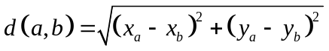,

where x and y represent the x- and y-coordinates of a and b respectively. Note that unlike other types of layers, distance layers are not an n_{rows} × n_{ccols} rectangular grid of values, but rather a matix of dimension (n_{rows} * n_{ccols}) × (n_{rows} * n_{ccols}) where the distance between each cell and every other cell is recorded. Note that the distance between any cell and itself is 0.

- Abundance layer: An abundance layer is simply the count of the number of individuals in each cell within categories K and with selectivity S. SPM calculates the values of an abundance layer when running the model at the point in time where the value is required. Here, the abundance at cell a is defined as

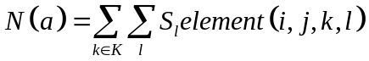

- Numeric layers. A model may have many numeric layers, and these can be used as covariates of a population or movement process (e.g., depth may be a covariate of some movement process), and/or locations of event mortality. Numeric layers can contain only continuous (numeric) variables. Values for a mumeric layer must be supplied for each cell by the user.

- Categorical layers. A model may have many categorical layers, and these are used as a classification or grouping variable for aggregating data over individual cells, e.g., management areas. Such layers are typically used to aggregate the population within cells into groups for comparing with observations. The values in layers used as categorical layers can contain any characters (except white space), and are interpreted as categorical values. Values for a categorical layer must be supplied for each cell by the user.

Note that SPM cannot ‘edit’ layers, including adding or otherwise combining layers that are supplied in the input parameter files — except in the case of numeric layers. Here, the numeric layer values can be supplied, and the values can optionally be normalised prior to use, i.e.,

L'(a) = L(a)/max(L),

i.e., L'(a) ≤ 1.

Observations

Observations are data which allow us to make inferences about the model parameter estimates. Examples include relative abundance indices, proportions-at-age in the catch, etc. The process of estimation in SPM involves finding values for each of the free parameters so that each observation is as close as possible to a corresponding expected value.

The population section

Overview

SPM is a discrete time-step state-space model, that represents the population age structure in a spatially explicit manner. The model is parameterised by both population processes (e.g., ageing, recruitment, mortality, and maturation), as well as movement processes.

The spatial structure of SPM is represented by a n_{rows} × n_{ccols} rectangular grid, with rows i=1..n_{rows} and columns j=1..n_{cols}. Each cell of the matrix contains a representation of the population structure at that point in space and is represented by a n_{categories} × n_{ages} rectangular matrix (with categories k=1..n_{categorioes} and ages l=age_{min}..age_{max}). Hence we can describe any spatial and population element of the model as element(i j,k,l).

A key input into SPM are layers. A layer is typically defined as a n_{rows} × n_{ccols} rectangular grid of values (with one exception — see later), where the value at each point represents a known quantity. For example layers may represent classifications, physical attributes, or other assumed quantities.

The population structure in SPM is represented by a matrix containing an arbitrary number of user defined categories (rows), and an arbitrary age range (columns). Hence, each spatial cell has a population state described as a n_{categories} × n_{ages} rectangular matrix with categories k=1..n_{categorioes} and ages l=age_{min}..age_{max}.

In order to model populations, the you need to define the years over which the model runs, and then for each year the movement and population processes that occur in the order that they occur. SPM used the term annual cycle to define the events that happen annually; and within the annual cycle, the number of time steps that occur; and within each time step, the population and movement processes in the order in which they occur. You can think of each time step as representing a particular part of the calendar year, or you can just treat them as an abstract sequence of events. The division of the year into an arbitrary number of time steps allows the user to specify the exact order in which processes and observations occur. The user needs to specify the time step in which each process occurs.

The model is run from a start_year for run_years. It can also be run past the current year to make projections (things that happen in the future) for a period of projection_years.

The state is the current status of the population, at any given time. The state can change one or more times in every time step of every year (depending on the number of processes that occur within that time step). SPM only knows the state immediately prior to apply a process, i.e., all previous states are ‘forgotten’. And, once applied, the previous is also ‘forgotten’

There are a number of possible processes that can change the state. These are grouped into two categories: population processes and movement processes: (i) Movement processes are defined as the process that move individuals between cells but retain the individuals population state, i.e., movement processes can only change an individuals spatial location; and (ii) Population process that can change the populations state within a spatial cell, but cannot change its spatial location. Hence, a model is made up from a sequence of movement processes to move individuals around inter-dispersed (in time) with population processes to recruit, age, apply mortality, etc. to the population.

The key element of the state is the partition (Bull et al. 2008). This is a broadly applicable concept that can be used to describe many different kinds of population model. The partition is simply a breakdown of the total number of individuals in the current population into groupds, for example age and category. (Note that in SPM, the partition records numbers of not biomass.) In SPM, individuals are categorised by both age class and by a user defined set of categories. Categories are entirely user defined, and may, for example, include male, female, immature, or mature categories.

Note that this structure can be used to implement quite complex models, with intermingling of separate stocks, with complex movement patterns using different event methods and covering different areas and at different times. However, typcially as complexity grows, the size of the model also grows. And, it may not be pratical to run or estimate parameters from complex models within the constraints of time or available computer memory.

The time sequence

The time sequence of the population model includes the years over which it is to run and the annual cycle for each year. The model runs from the start of year start_year and runs for a total of run_years. Projections extend the run period by projection_years. Initialisation of the model (see later) is carried oput by running the model for initial_years.

Within each year, the annual cycle can contain the following movement and population processes:

Movement processes
- Square or hexagonal uniform movement
- Square or hexagonal density dependent movement
- Square or hexagonal density independent movement
- Directed movement

Population processes
- Ageing (in an age-based model).
- Recruitment.
- Natural mortality
- Event mortality
- Category transition

If two or more processes are specified for the same time step then they will happen in the order defined in the population.SPM input file.

To specify the time sequence, you need to tell SPM the following:

- The initial, start, and number of run years.
- The number of time steps in each year.
- The processes that occur in each time step, in the order that they occur

You then need to provide SPM with details about how each process works. These processes can be complex to define, and they are described individually in Section 5.3 (population processes) and Section 5.4 (movement processes).

When you define your annual cycle, there are a number of errors you can be made. SPM has limited ability to validate or verify that your annual cycle is sensible. For example it is possible to have a category that remains un-aged, suffers no natural mortality, or is even unused by the model. SPM does not check that you have correctly or logically defined your annual cycle or the processes that make up the annual cycle.

Population processes

This section describes the various population processes in SPM. The available population processes are:

- Ageing i.e., age incrementation
- Recruitment
- Natural mortality
- Event mortality
- Category transition

Ageing

The ageing process is straightforward. Every individual increases in age by one year, except those already in the plus age group (if it exists), which are unaffected. Note that if there is no plus group in the partition, then all individuals older then the maximum age are “dropped off” the end of the partition. It is permissible to have more that one ageing process per year (although, unless you have multiple stocks, this may not be sensible).

Ageing cannot depend on a layer, nor a selectivity, and occurs for some or all categories.

Recruitment

In the recruitment process, a number of individuals are added to the partition. All recruiting individuals are recruited to the minimum age in the partition, into user defined categories. It is permissible to have more than one recruitment event per year.

For each recruitment event, the number of individuals added in year y is

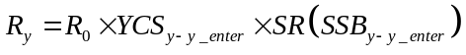 (R1)

where R₀ is the stock’s average recruitment (ignoring the stock-recruitment and climate-recruitment functions); YCS are year class strength multipliers (also known as recruitment multipliers); y_{enter} is the number of years after it is spawned that a year class enters the partition; SR is the stock-recruitment function (SR ≡ 1 if there is no stock-recruitment relationship, and note SR allways equals one if the model in within the initialisation period). For early years, if y–y_{enter} < start_year, then SPM sets SSB_{y-y_enter} to B₀.

However, within SPM, SSB is not a predefined quantity. You need to tell SPM how to calculate SSB for each year. And because there can be many SSBs within a model (for example, with multiple stocks), you need to tell SPM which one to use. There is no requirement for SSB to be male, female, or even mature biomass — it is simply a quantity (determined from the population) that is user defined.

You should provide YCSs starting from year (initial-y_{enter}) and extending up to year (current-y_{enter}).

Note that the value of y_{enter} depends on the order of recruitment, ageing, and spawning processes within a year:

- If recruitment then ageing then spawning, then y_{enter} should equal min_age+1.
- If spawning then ageing then recruitment, then y_{enter} should equal min_age-1.
- If any other order, then y_{enter} should equal min_age.

SPM will output a warning if the value of y_{enter} you supply does not obey the above rule, but will continue running.

One quantity the user can choose to output is the true_YCS (see Section Error: Reference source not found), which differ from the YCS by including contributions from SR and CR. That is, they are defined as true_YCS_{y} = R_{y+y_enter}/R₀.

Recruitment can depend on a layer. Here only one method of dependance is implemented, the uniform method. The uniform recruitment method defines that the cells that receive recruitment are those cells where the values of a layer are in a range between a user defined minimum and maximum value. Recruitment can be also split between categories, but cannot depend on a selectivity-at-age. Hence, given R_{y}, if we denote the recruitment to category k in cell a as R_{y}(a,k), then

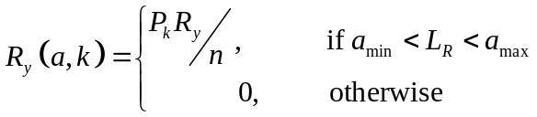,

where P_{k} is the proportion that recruit to category k, n is the number of cells in L_{R} where a_{min} < L_{R} < a_{max}, and 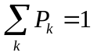.

Stock-recruitment functions

The only stock-recruitment function available is Beverton-Holt. This is parameterised by the parameter steepness, defined as h=SR(0.2B₀). The functional forms for this relationship is:

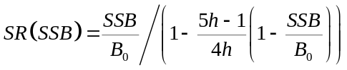

Ensuring R₀ makes sense

As noted above, R₀ is intended to represent the recruitment that would typically occur if there were no non-natural mortality. SPM provides a single method for the user to ensure that their estimate of R₀ has this meaning (the Haist parameterisation, as suggested by V. Haist for SPM Bull et al. 2008).

Here, we assume the model parameter YCS is a vector Y, covering years from initial-y_enter+n_rinitial to current-y_enter. The year class strengths are then calculated by YCS_{i}=Y_{i}/mean(Y_{i}) where the mean is calculated over the user-specified years first_free to last_free. Then,

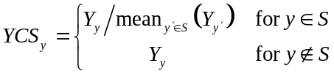

where S is the set of years from first_free to last_free. One effect of this parameterisation is that R₀ is now defined to be the mean estimated recruitment over the years first_free to last_free (because the mean YCS over these years will always be 1). Typically, the user will define first_free and last_free to span the years for which they expect to have reasonable estimates of YCSs. Often, the user will wish to force Y_{y}=1 for some or all years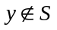 (this is equivalent to forcing R_{y}=R₀ x SR x CR) by setting the lower and upper bounds of these Ys to be 1. An exception to this might occur for the most recent YCSs, which the user may want to estimate, but not include in the definition of R₀ (because the estimates are based on too few data).

The advantage of this parameterisation is that mean of the YCS parameter is defined to be 1, but a small penalty may need to be applied to stop the mean of Y from drifting. A disadvantage with this parameterisation in a Bayesian analysis is that the prior refers to the Y’s, not the YCS.

Specifying recruitment

So, to specify the recruitment for each stock, you need to tell SPM the following:

- YCS, starting from year (initial-y_{enter}+n_{rinitial}) and extending up to year (current-y_{enter}).

- The value of y_{enter}.

- The stock-recruitment function (if any) and the steepness parameter.

- The category and ages to which recruits are added.

Natural Mortality

Two mortality processes are permissible in SPM, natural and event. Both processes remove individuals from the partition. SPM does not implement the Baranov catch equation or any other process where both natural and event mortality can be concurrently applied. To approximate concurrent natural and event mortality, the population processes must be defined to remove some natural, then some event mortality in sequence. It is up to the user to specify how this happens.

Natural mortality can depend on a layer. Here only one method of dependance is implemented, the multiplicative method. The multiplicative natural mortality method defines that the value of instantaneous natural mortality applied to the population state within each cell is the product of the layer value, a selectivity-at-age, and a natural mortality rate. Hence, let the mortality rate applied to the population at cell a in category k and age l be denoted M(a,k,l), and given a value from a layer L_{a} at a, a natural morality rate M, and a selectivity-at-age S_{l} at age l for some user-defined categories k then,

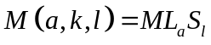,

And the resulting number of indivuiduals remaining in cell a in category k at age l from applying a natural mortality process is then calcuated as,

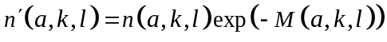

Event mortality

Event mortality acts in a similar manner to natural mortality, except that it removes a specified number of indivuduals from the partition, rather than applying a mortality rate. However, the maximum number of indioviduals to reemoive is contraned by a maximum exploitation rate.

Event mortality must be defined using a layer. Here, the number of individuals to remove from a the population for each cell a is the value of the layer at a (denoted F_{a}) — except where there are too few individuals for the event mortality to be taken (as defined by the maximum exploitation rate). In this scenario, SPM removes as many individuals as it can while not exceeding the maximum exploitation rate.

Event mortality is applied to user-defined categories k, with the numbers removed at age l determined by a selectivity-at-age S_{l}. and is applied as follows,

First, calculate the vulnerable abundance for each category k in 1 to K for ages l in 1 to L that are subject to event mortality,

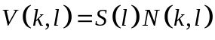

And hence define the total vulnerable abundance as,

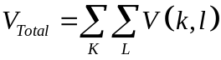

Hence the exploitation rate to apply is

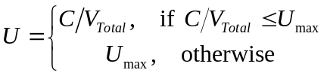

And the number removed from each age l in category k is,

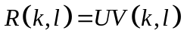

Category transitions

Movement processes

Square and hexagonal movement

Uniform

Density dependent

Density independent

Directed movement

Setting the initial state

Before setting the initial state of the population you need to supply the equilibrium abundance for each stock. Usually, this is done by specifying either R₀ (equilibrium constant recruitment level, as a number of individuals).

The algorithm for determining the equilibrium state involves running the model over a number of simulated years with constant recruitment. You need to tell it how many years to use; this would usually be the twice the approximate maximum age of the individuals.

So, to specify the initial state of the population, you need to supply:

- R₀

- The number of years in the constant-recruitment simulations used to determine the equilibrium state.

Applying selectivities

An selectivity is a function with a different value for each age class (i.e., for each column of the partition). Selectivities are used frequently throughout the SPM population section: for selectivity curves.

Selectivities have a number of different parametric forms in SPM and you can use any of these for any selectivity parameter. Some common parameterisations are logistic, knife_edge, double_normal, and the most flexible parameterisation allvalues where each selectivity element is specified separately. See Section 3.4 for instructions on specifying Selectivities in SPM.

An selectivity is always defined to apply just to one category (or row) or the population. To apply the same selectivity to more than one category, the you need to specify the rows that it applied to.

Note that selectivities are indexed by age, with indices from min_age to max_age. For example, you might have an age-based selectivity that was logistic with 50% mark at age 5 and 95% mark at age 7. This would be defined by subgroup logistic, a₅₀=5, a_{to95}=(7-5)=2. Then the value of the selectivity at age x=3 is 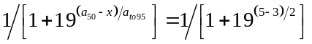.

Note that the function values for some choices of parameters for some Selectivities can result in an computer numeric overflow error (i.e., the number calculated from parameter values is either too large or too small to be represented in computer memory). SPM implements range checks on some parameters to test for a possible numeric overflow error before attempting to calculate function values. For example, the logistic selectivity is implemented such that if (a₅₀-x)/a_{to_95} > 5) then the value of the selectivity at x is zero, i.e., for a₅₀=5, a_{to_95}=0.1, then the value of the selectivity at x=1, without range checking would be 7.1x10⁻⁵². With range checking, that value is 0 (as (a₅₀-x)/a_{to_95}=40 > 5).

Selectivity descriptions

The available Selectivities are described below. Table 1 summarises the available selectivities.

constant

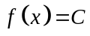

The constant selectivity has the estimable parameter C.

allvalues

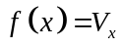

The allvalues selectivity has estimable parameters V_{low} V_{low+1} … V_{high}. Here, you need to provide an selectivity value for each age class.

allvalues_bounded

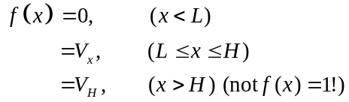

The allvalues_bounded selectivity has non-estimable parameters L and H. The estimable parameters are V_{L} V_{L+1} … V_{H}. Here, you need to provide an selectivity value for each age class.

logistic

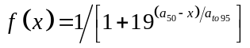

The logistic selectivity has estimable parameters a₅₀ and a_{to95}. The logistic selectivity takes values 0.5 at x=a₅₀ and 0.95 at x=a₅₀+a_{to95}.

double_normal

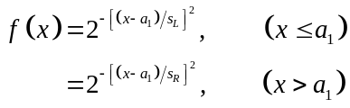

The double_normal selectivity has estimable parameters a₁, s_{L}, and s_{R}. It has values 1 at x=a₁, and 0.5 at x=a₁-s_{L} or x=a₁+s_{R}.

logistic_producing

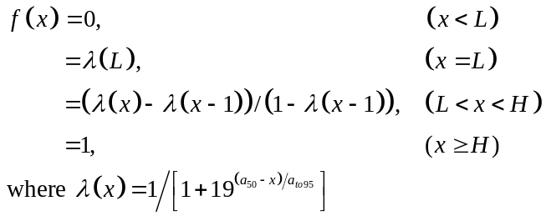

The logistic_producing selectivity has the non-estimable parameters L and H, and has estimable parameters a₅₀ and a_{to95}. For category transitions, f(x) represents the proportion moving, not the proportion that have moved. This selectivity was designed for use in an age-based model to model maturity. In such a model, a logistic_producing maturation selectivity will (in the absence of other influences) make the proportions mature follow a logistic curve with parameters a₅₀, a_{to9}.

double_exponential

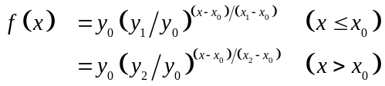

The double_exponential selectivity has non-estimable parameters x₁ and x₂, and estimable parameters x₀, y₀, y₁, and y₂. It can be ‘U-shaped’. Bounds for x₀ must be such that x₁ < x₀ < x₂. The selectivity passes through the points (x₁, y₁), (x₀, y₀), and (x₂, y₂). If both y₁ and y₂ are greater than y₀ the selectivity is ‘U-shaped’ with minimum at (x₀, y₀).

Table 1: Summary of the selectivitys available in SPM, their parameters, and if they can be shifted or used as a length-based selectivity in an age based model.
Selectivity | Parameters |  | Shift? | Length-
 | Non-estimable | Estimable |  | based?
constant |  | C | Yes | Yes
allvalues |  | V_{low} V_{low+1} … V_{high} | No | No
allvalues_bounded | L H | V_{L} V_{L+1} … V_{H} | No | No
logistic |  | a₅₀ a_{to95} | Yes | Yes
double_normal |  | a₁ s_{L} s_{R} | Yes | Yes
logistic_producing | L H | a₅₀ a_{to95} | No | No
double_exponential | x₁, x₂ | x₀, y₀, y₁, y₂ | No | Yes

The estimation section

Role of the estimation section

The tasks carried out by the estimation section are:

- Get the point estimate, i.e., the maximum likelihood estimate (MLE) or maximum posterior density estimate (MPD) (see Section 6.3).

- Profile selected parameters, i.e., find, for each of a series of values of a parameter, allowing all other free parameters to vary, the minimum value of the objective function (Section 6.4). This is called either a likelihood or posterior profile.

- For Bayesian estimation only, generate an MCMC sample from the posterior distribution (Section 6.5).

- For maximum likelihood or Bayesian estimation, calculate the approximate covariance matrix of the parameters as the inverse of the minimiser’s approximation to the Hessian, and the corresponding correlation matrix (Section 6.3).

Specifying the free parameters

You need to tell SPM which of the estimable parameters are to be freed by using @estimate commands (see Section 9). An @estimate command-block looks like this,

@estimate
parameter initialization.B0
lower_bound 1000
upper_bound 100000
prior uniform

See Section 3.4 for instructions on how to generate the parameter name. You have to specify at least one free parameter. You still provide values for the free parameters as normal, these are used as the starting values for the minimiser (unless you provide alternative starting values using SPM -i, see Section 3.1).

All parameters are estimated within bounds. For each free parameter (scalar, vector, or selectivity), you need to specify the bounds, and, in a Bayesian analysis, the prior (Section 6.7.4). Note that the bounds and prior on an selectivity refer to the selectivity free parameters, not the actual values of the selectivity.

You need to estimate all the estimable parameters of an selectivity if you estimate any, but you can fix some of them if you want by setting the lower and upper bound equal. Similarly, if you want to estimate only some elements of a vector, fix the others by setting the bounds equal.

Catchability coefficients q are a bit of a special case, because no starting value is provided in the nuisance method (see Section 6.7.1) whereas all other free parameters always need starting values. But you still need to provide an @estimate block for each q, containing the bounds on the q, using the following format,

@estimate
parameter q[label].q
lower_bound 1e-6
upper_bound 1e-2

where label is the label of the q in the observations blocks. If you’re still uncertain how to do this then look at the example in Section 13.

If you want to estimate two (scalar, vector, or selectivity) parameters and to constrain them to be the same, you need to use the same subcommand. This might arise if, for example, you wanted to use the same migration selectivity for two different migrations involving different stocks. Only use one @estimate block, for one or other of the two parameters. Put in the same command, using the name of the other parameter as the argument. For example,

@estimate
parameter growth[1].g
same growth[2].g
…

means that the g parameters for the first two growth episodes are both estimated, but constrained to be equal. (Don’t put in a second @estimate block for growth[2].g with same growth[1].g.)

Point estimation

Point estimation is invoked with SPM -e, and also used in several other tasks. Mathematically, it is an attempt to find a minimum of the objective function. SPM approaches this optimisation problem using a quasi-Newton minimiser built into Betadiff, which is a slightly modified implementation of the main algorithm of Dennis Jr. & Schnabel (1996).

The minimiser has three kinds of (non-error) exit status:

- Successful convergence (suggests you have found a local minimum, at least).

- Failure to converge (you have not reached a local minimum, though you may deem yourself to be ‘close enough’ at your own risk).

- Convergence unclear (the minimiser has clunked to a halt. You may have found a local minimum, although you should check by restarting the minimiser at the final values of the free parameters).

You can choose the maximum number of quasi-Newton iterations and objective function evaluations allotted to the minimiser. If it exceeds either limit, it exits with a convergence failure. We urge you to use large numbers of evaluations and iterations (at least the defaults of 300 and 1000) unless you successfully reach convergence with less. You can also specify the starting point of the minimiser using SPM -i.

We want to stress that this is a local optimisation algorithm trying to solve a global optimisation problem. What this means is that, even if you get a ‘successful convergence’ message, your solution may be only a local minimum, not a global one. To diagnose this problem, try doing multiple runs from different starting points and comparing the results, or (probably better) doing profiles of one or more key parameters and seeing if any of the profiled estimates is actually better than the original point estimate. Otherwise you may have reached a false (local) minimum.

The approximate covariance matrix of the free parameters can be calculated as the inverse of the minimiser’s approximation to the Hessian, and the corresponding correlation matrix is also calculated. These results are printed if you use the print.covariance parameter (and, optionally, the eigen values of the Hessian, see Section 10.1). Be aware (i) that the Hessian approximation develops over many minimiser steps, so if the minimiser has only run for a small number of iterations the covariance matrix can be a very poor approximation, (ii) in any case the inverse Hessian is not a good approximation to the covariance matrix of the free parameters, and should not be used, for example, to construct confidence intervals. Also note that if a free parameter has equal lower and upper bounds, it will have entries of ‘0’ in the covariance matrix and ‘NaN’ or ‘-1.#IND’ (depending on the operating system) in the correlation matrix.

Posterior profiles

If profiles are requested (SPM -p), SPM will first calculate a point estimate. For each scalar parameter or, in the case of vectors or selectivities, the element of the parameter to be profiled, SPM will fix its value at a sequence of n evenly spaced numbers between specified bounds l and u, and calculate a point estimate at each value. By default n=10, and (l, u)=(lower bound on parameter plus (range/(2n)), upper bound on parameter less (range/(2n)). Each minimisation starts at the final parameter values from the previous resulting value of the parameter being profiled. The program reports the objective function for each parameter value, and all the parameter estimates. The initial point estimate is also inserted into the profile (note that this can serve as a check that none of the other points along the profile have a better objective function value than the initial ‘minimum’).

You specify which parameters are to be profiled, and optionally n, l, and u values for each. In the case of vector or selectivity parameters, you will also need to specify the element of the vector being profiled.

You can also supply the initial point estimate using SPM -i, so that SPM doesn’t need to do the first minimisation. Be aware that you are supplying the point estimate, not the minimiser starting point to get to the point estimate (as in other situations where SPM -i is used).

If you have specified multi-phase estimation (see Section 6.3), it is only used for the initial point estimate. Subsequent minimisations are done single-phase, as they should start reasonably close to the endpoint and so shouldn’t need multiple phases.

If you are doing a Bayesian analysis and want likelihood profiles rather than posterior profiles, then either switch to the likelihood objective function (using @estimator likelihood) for the duration or make all the priors uninformed.

If you get an implausible profile, it may be a result of not using enough iterations in the minimiser (in this case, increase max_iters and/or max_evals and retry), or the convergence criteria may not be strong enough (try setting grad_tol to a smaller value).

You can direct the profile estimates to an output parameter file with the command line option -O (see Section 3.2). Note that if you use the -O command line option, then, following the completion of the profile estimates, SPM will use this file as the input parameter file for a -r run. The results from the -r run will then be appended to standard output.

Bayesian estimation

SPM can:

- Use a Monte Carlo Markov Chain to generate a sample from the posterior distribution of the free parameters (SPM -m); and output the sampled values to a file, (optionally only every nth set of values).

- If the run is interrupted, recover the results from the file and continue the run from where it left off, appending the results to the file (SPM -a).

- Combine the results of one or more chains into a single posterior sample by removing samples from the ‘burn-in’ periods and concatenating the results; allow the user to reduce the size of the resulting sample by sub-sampling; and optionally, apply prior re-weighting in the sub-sampling process, i.e., apply probability weights to generate a sample from a posterior based on a different prior (SPM -C). The sub-sampling may be either systematic (every nth point) or randomly (with replacement). The former is recommended (to minimise autocorrelation) except with prior re-weighting, when the latter must be used.

- For a posterior sample, calculate the values of various output quantities at each sample point and export these so that they can be plotted and/or summarised using an external package (use SPM -v).

Two major steps are best done by an external package, as SPM has no post-processing capabilities. SPM cannot:

- Produce MCMC convergence diagnostics (use a package such as BOA, see www.public-health.uiowa.edu/boa).

- Plot/summarize the posterior distributions of the output quantities (for example, using a general-purpose statistical or spreadsheet package such as S-Plus, R, or Microsoft Excel).

Bayesian methodology and MCMC are both large and complex topics, and we do not describe either properly here. See Gelman et al. (1995) and Gilks et al. (1998) for details of both Bayesian analysis and MCMC methods. In addition, see Punt & Hilborn (2001) for an introduction to quantitative fish stock assessment using Bayesian methods.

This section only briefly describes the MCMC algorithms used in SPM. See Section 3.2 for a better description of the sequence of SPM commands used in a full Bayesian analysis.

SPM uses a straightforward implementation of the Metropolis algorithm (Gelman et al. 1995, Gilks et al. 1998). The Metropolis algorithm attempts to draw a sample from a Bayesian posterior distribution, and calculates the posterior density π, scaled by an unknown constant. The algorithm generates a ‘chain’ or sequence of values. Typically the beginning of the chain is discarded and every Nth element of the remainder is taken as the posterior sample. The chain is produced by taking an initial point x₀ and repeatedly applying the following rule, where x_{i} is the current point:

- Draw a candidate step s from a proposal distribution J, which should be symmetric i.e., J(-s)=J(s).

- Calculate r=min(π(x_{i}+s)/π(x_{i}),1).

- Let x_{i+1}=x_{i}+s with probability r, or x_{i} with probability 1-r.

An initial point estimate is produced before the chain starts, which is done so as to calculate the approximate covariance matrix of the free parameters (as the inverse Hessian), and may also be used as the starting point of the chain.

The user can specify the starting point of the point estimate minimiser using SPM -i. Don’t start it too close to the actual estimate (either by using SPM -i, or by changing the parameter values in population.SPM) as it takes a few iterations to form a reasonable approximation to the Hessian.

There are three options for the starting point of the Markov Chain:

- Start from the point estimate.

- Start from a random point near the point estimate (the point is generated from a multivariate normal distribution, centred on the point estimate, with covariance equal to the inverse Hessian times a user-specified constant). This is done to prevent the chain from getting ‘stuck’ at the point estimate.)

- Start from a point specified by the user with SPM -i.

The chain moves in natural space, i.e., no transformations are applied to the free parameters. The default proposal distribution is a multivariate normal centred on the current point, with covariance matrix equal to a matrix based on the approximate covariance produced by the minimiser, times some stepsize factor. The following steps define the initial covariance matrix of the proposal distribution:

- The covariance matrix is taken as the inverse of the approximate Hessian from the quasi-Newton minimiser.

- The covariance matrix is modified so as to decrease all correlations greater than max_cor down to max_cor, and similarly to increase all correlations less than -max_cor up to -max_cor (the max_cor parameter defaults to 0.8). This should help to avoid getting ‘stuck’ in a lower-dimensional subspace.

- The covariance matrix is then modified either by,

  - adjustment_method=covariance: that if the variance of the ith parameter is nonzero and less than min_diff times the difference between the parameters’ lower and upper bound, then the variance is changed, without changing the associated correlations, to k=min_diff(upper_bound_{i}-lower_bound_{i}). This is done by setting 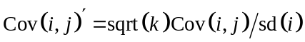 for 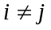, and 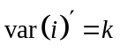.

  - adjustment_method=correlation: that if the variance of the ith parameter is nonzero and less than min_diff times the difference between the parameters’ lower and upper bound, then its variance is changed to min_diff(upper_bound_{i}-lower_bound_{i}). This differs from (i) above in that the effect of this option is that it also modifies the resulting correlations between the ith parameter and all other parameters.

This allows a free parameter to move in the MCMC even if its variance is very small according to the inverse Hessian. In both cases, the min_diff parameter defaults to 0.0001.

- The stepsize (a scalar factor applied to the covariance matrix to improve the acceptance probability) is chosen by the user. The default is 2.4d^{-0.5} where d is the number of free parameters, as recommended by Gelman et al. (1995), though experience has shown that this is often too high, leading to a very low acceptance rate.

The proposal distribution can also change adaptively during the chain, using two different mechanisms. Both are offered as means of improving the convergence properties of the chain. It is important to note that any adaptive behaviour must finish before the end of the burn-in period, i.e., the proposal distribution must be finalised before the kept portion of the chain starts (SPM enforces this). The adaptive mechanisms are as follows:

- You can request that the step size change adaptively at one or more sample numbers. At each adaptation, the step size is doubled if the acceptance rate since the last adaptation is more than 0.5, or halved if the acceptance rate is less than 0.2. (See Gelman et al. 1995 for justification.) The new step size is recorded in the objectives file.

2. You can request that the entire covariance matrix change adaptively at one or more sample numbers. At each adaptation, it is replaced with a matrix based on the sample covariance of an earlier section of the chain. The theory here is that the covariance of a portion of chain could potentially be a better estimate of the covariance of the posterior distribution than the inverse Hessian.

The procedure used to choose the sample of points is as follows. First, all points on the chain so far are taken. All points in an initial user-specified period are discarded. The assumption is that the chain will have started moving during this period — if this is incorrect and the chain has still not moved by the end of this period, it is a fatal error and SPM stops. The remaining set of points must contain at least some user-specified number of transitions — if this is incorrect and the chain has not moved this often, it is again a fatal error. If this test is passed, the set of points is systematically sub-sampled down to 1000 points (it must be at least this long to start with).

The variance-covariance matrix of this sub-sample of chain is calculated. As above, correlations greater than max_cor are reduced to max_cor, correlations less than -max_cor are increased to -max_cor, and very small nonzero variances are increased (covariance_adjustment and min_diff). The result is the new variance-covariance matrix of the proposal distribution.

The step size parameter is now on a completely different scale, and must also be reset. It is set to a user-specified value (which may or may not be the same as the initial step size). We recommend that some of the step size adaptations are set to occur after this, so that the step size can be readjusted to an appropriate value which gives good acceptance probabilities with the new matrix.

All modified versions of the covariance matrix are printed to the standard output, but only the initial covariance matrix (inverse Hessian) is saved to the objectives file. (As a consequence, a lapsed chain cannot be continued using -a if adaptive covariance is used.) The number of covariance modifications by each iteration is recorded as a column on the objectives file.

The probability of acceptance for each jump is 0 if it would move out of the bounds, or 1 if it improves the posterior, or (new posterior/old posterior) otherwise.

You can specify how often the position of the chain is recorded using the keep parameter. For example, with keep 10, only every 10th sample is written to file.

You have the option to specify that some of the free parameters are fixed during MCMC. If the chain starts at the point estimate or at a random location, these fixed parameters are set to their values at the point estimate. If you specify the start of the chain using -i, these fixed parameters are set to the values in the file.

A multivariate t distribution is available as an alternative to the multivariate normal proposal distribution. If you request multivariate t proposals, you may want to change the degrees of freedom from the default of 4. As the degrees of freedom decrease, the t distribution becomes more heavy tailed. This may lead to better convergence properties.

Having produced one or more Markov chains and looked at the diagnostics, you should reload all the chain output files into SPM and use them to generate a single posterior sample (using -C). At this stage, the first burn_in iterations for each chain are discarded (so, with keep 10, burn_in 1000, the first 1000 recorded samples are discarded for each chain). Unless a very large value of keep was originally chosen, it will be necessary to further reduce the size of the posterior sample (possibly down to several hundred) such that it can be analysed in a reasonable amount of time. This is done by sub-sampling. You specify the size of the sub-sample to be produced (or else no sub-sampling is done). You have the option to generate a systematic sub-sample (i.e., every nth point is kept) or a random sub-sample (the former is recommended except with prior re-weighting, when the latter must be used).

Given a posterior (sub)sample, SPM can calculate a list of output quantities for each sample point (see Section Error: Reference source not found). These quantities can be dumped into a file (using SPM -v) and read into an external software package where the posterior distributions can be plotted and/or summarised.

The posterior sample can also be used for projections (Section 7.2) and stochastic yield calculations (Section Error: Reference source not found). The advantage of this is that the parameter uncertainty, as expressed in your posterior distribution, can be included into the risk and yield estimates.

It is possible to investigate the results that you would have got if you had used a different prior. This is called prior re-weighting and is done by calculating the ratio of the new prior to the original prior for each point in the posterior sample, then using these ratios as probability weights when generating a random (not systematic) sub-sample with SPM -C. Prior re-weighting is applicable only if the new prior is zero in every part of the parameter space for which the original prior was zero. Also, it is likely to be numerically unstable unless the new prior is very small in every part of the parameter space for which the original prior was very small.

Observations

The objective function is based on the goodness-of-fit of the model to your observations. In the current release of SPM, most observations are different kinds of time series, i.e., data which were recorded for one or more years, in the same format each year. Examples of time series data types include relative abundance indices, commercial catch length frequencies, survey numbers-at-age, etc,.

Generally, time series must relate to a specified time step, and a specified area if the model is spatial, and one or more years in which they were recorded. These are the exceptions; (a) catch-at data (see below) can be based on more than one fishery and hence can cover multiple areas or time steps, and (b) age-at-maturation data (see below) are not associated with a year, time step, or area.

Types of observations

Each time series of observations belongs to one of the following types:

- Abundance: including survey biomass indices and CPUE. Can be absolute abundance or relative abundance. Can be expressed as biomass or numbers of fish.

- Catch-at: including commercial catch proportions-at-age and proportions-at-size. Can be split by sex.

- Numbers-at: including survey numbers-at-age and numbers-at-size. Can be absolute numbers or relative numbers. Can be split by sex.

- Proportions-at: including survey proportions-at-age and proportions-at-size. Can be split by sex.

- Proportions mature: i.e., data on the proportion of fish, by age or size class, which are mature. If you are using age frequency observations in an age-based model, you need to say which age classes are included and whether the last age class is a plus group. For example, your partition might include ages from 1 to 20+ but you might have observations only for 2, 3, 4, 5, and 6+ aged fish. The same applies to size frequency observations in a size-based model.

- Proportions migrating: i.e., data on the proportion of fish, by age or size class, which went on a particular migration. More specifically, for each age/size class, the number of migrating fish (in the source area of the migration, including all stocks) divided by the total number of fish (in the source area of the migration, including all stocks). Can be provided for either sex, or both combined.

- Age size: i.e., observations of the ages and sizes of individual fish — primarily used to fit size-at-age parameters in age-based models. See below.

- Age-at-maturation: a specialised observation type, used for modelling orange roughy and potentially other fish with similar characteristics. The age at which a mature orange roughy became mature can be estimated by examining the otolith after capture. The age-at-maturation data type allows SPM to use this information for estimation of maturation parameters. See below.

- Selectivity-at: an unusual observation type, and should be used only when you have some direct observations of the values of a selectivity (to date we have only seen this in a single shellfish model).

- Tag-release: observations on the sizes of tagged fish in tag-release event, and should only be used when tagging is part of the partition in an age-based model and if the tag release type is free (see Section Error: Reference source not found)

- Tag-recapture: observations on the numbers of tagged (and scanned) fish recaptured from a tag-release event, and should only be used when tagging is part of the partition.

For each time series, as well as the above, you need to provide SPM the following information:

- A label. (This should be unique, neither “Bpre” or “Bpost”, and should not contain a full stop.)

- The years in which they were observed.

- For catch-at observations, the fishery or fisheries they cover.

- For all observations except catch-at and age-at-maturation:
- The area in which they were observed (in a multi-area model).
- After what proportion of the mortality in the time step they occurred. (This is a useful option as it allows you to insert an observation partway through a time step, which can sometimes avoid splitting the time step into two.).
- The name of the selectivity (except for tag-release and some options for tag-recapture observations) which should be applied, if any (trawl survey data should use the selectivity of the research vessel; CPUE data could arguably use the selectivity of the commercial fleet).

- If you are using age frequency observations in an age-based model, you need to say which age classes are included and whether the last age class is a plus group. For example, you might have observations of 2, 3, 4, 5, and 6+ aged fish. The same applies to size frequency observations in a size-based model.

- If you are using a set of size frequency observations in an age-based model, you need to provide the size classes. (In a size-based model, the size bins used in the observations must be consecutive groupings of the bins defined in the population section of the model.)

- For catch-at and proportions-at observations, you need to specify whether the observations and fits for each year should sum to 1.

If you say that proportions must sum to 1, the SPM calculates the expected values using a denominator constructed from the number of fish in the age or size classes included in the range specified in the observations.

Otherwise, if you do not force the proportions to sum to 1, then the expected values are calculated using a denominator of the total number of fish in all age or size classes in the partition. This approach was intended for backwards compatibility with previous least-squares estimation software and may not always work in likelihood analysis.

The setting sum_to_one true is the default and is recommended. If the observations don’t sum to 1 (and this is determined for each year independently), a warning is printed and the observations (for that year) are rescaled to sum to 1. (Note the test for observations summing to 1 is implemented with a tolerance of ±0.01.)

- For relative observations, you need to provide the label of the catchability coefficients q. Several time series can share the same q (see Section 6.7.1). You can also provide a curvature parameter b for non-linear relationships (see Section 6.7.1).

- For at-age data, whether ageing error should be applied (Section 6.7.6). It may be the case that you have defined an ageing error but don’t want to apply it to one or more of your time series, perhaps because the ageing error is meant to be included in the likelihood.

- For tag-release observations, the numbers released by size class.

- For tag-recapture observations, the detection probability, and the numbers scanned and recaptured.

- For likelihood or Bayesian analysis, you need to provide the error distribution and its parameters (the error distributions are listed in Section 6.7.1). For variability parameters (c.v.s, standard deviations, and effective sample sizes N), there can either be one value for all years, or one value per year, or (for at-age or at-size data), one value per age/size class per year. Note that c.v.s are expressed as a proportion not a percentage, for example, if you put a c.v. of 40 then you probably meant 0.4. See also specifying the process error (Section 6.7.2).

- And of course you have to provide the observation values. Abundance values are straightforward — one number per year. At-age or at-size data are a bit more complicated. There is one row of numbers for each year, one column per age/size class. If the observations are sexed, then there are male columns followed by female columns, rather than separate male and female tables. Age-size and age-at- maturation data are input as several rows of data, one per variable: age, size and potentially sex for age-size, and age at capture, age at maturation and potentially sex for age-at-maturation

The objective function

In maximum likelihood estimation, the objective function is a negative log-likelihood,

Objective (p)= 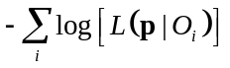

where p is a vector of the free parameters, L the likelihood function and O_{i} the ith observation.

In Bayesian estimation, the objective function is a negative log-posterior,

Objective (p)= 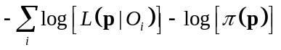
where π is the joint prior density of the parameters p.

Under either estimation method, penalties can be added to the objective function (see Section 6.7.5). You will usually want to use penalties to ensure that the exploitation rate constraints on your fisheries are not breached (otherwise there is nothing to prevent the model from having abundances so low that the recorded catches could not have been taken). A penalty to force the YCS to average to 1 (i.e., to have mean 1) may also be necessary.

Likelihoods

SPM has five different kinds of likelihoods:

- Those used for proportions data, where the proportions should sum to 1 over the columns of the partition. This includes commercial and survey proportions-at-size and proportions-at-age data, but not proportions mature or proportions migrating.

- Those used for proportions data, where the proportion can be between 0 and 1 in each cell, and need not sum to 1 over the columns of the partition. This includes selectivity at, proportions mature, and proportions migrating.

- Those used for absolute index data. These likelihoods are used for absolute abundance and can also be used for selectivity at, proportions mature, and proportions migrating.

- Those used for relative index data, including relative abundance and relative survey numbers-at-age.

- Specialized likelihoods used for age-size data, age-at-maturation data, or tag-release/recapture events — see Section 6.6 for details about the specialized likelihoods.

See also Section 6.7.2 for detail about process error.

Likelihoods for proportions data (with proportions summing to 1 across columns of the partition)

These likelihoods are used for commercial and survey proportions-at-size and proportions-at-age data, but not proportions mature or proportions migrating. They apply to data which are distributed across columns of the partition, typically summing to 1 across columns.”

Let O be the observations for a single year in a proportions time series, expressed as a vector of n proportions summing to 1; let E be the corresponding fitted values; let N be the “effective sample size” parameter. Then you can use the following likelihoods, which are expressed on the objective-function scale of -log(L):

- Multinomial

where Z(x,r) is a robustifying function with parameter r>0 (to prevent division by zero errors), defined as

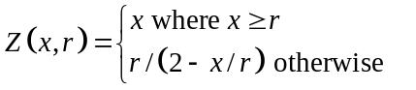

- Fournier

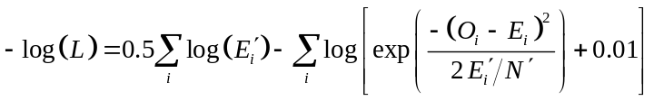

where 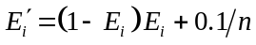 and 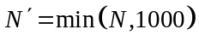.

This is a robustified multivariate normal (it would be the usual multivariate normal with σ²=(1-E_{i})E_{i}/N if the 0.1/n and 0.01 terms are omitted and if 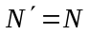). See Fournier et al. (1990).

- Coleraine. As per Fournier above, but replace 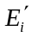 with 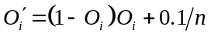. A recent reference is Starr et al. (1999).

- (Robustified) lognormal

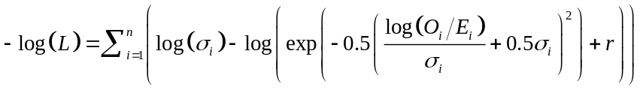

where 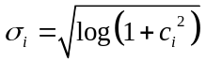, the c_{i}’s are c.v.s by age/size class, and r is a robustifying constant.

The robustification term r is intended to reduce the influence of outliers, in the same way as the robustified Fournier likelihoods above. We recommend r=0.01, though smaller values (0.001, 0.0001, …) could be used for a lesser robustifying effect.

Likelihoods for proportions data (with proportions between 0 and 1 in each cell)

These likelihoods are used for proportions mature and proportions migrating data. They apply to data which can be between 0 and 1 in each cell, not necessarily summing to 1 across columns.

So far there is just one likelihood in this category, the binomial, but this is implemented in two forms; the standard binomial (termed “binomial”), and the normal approximation to the binomial (“binomial-approx”).

Let O_{i} be the observations for a single year in a time series, expressed as a vector of n proportions between 0 and 1; let E_{i} be the corresponding fitted values; let N_{i} be the “effective sample size” parameter for each observed proportion. A single effective sample size may be specified for all observations in a given year, or different sample sizes may be specified for each observation in the year. Then the binomial likelihood, which is expressed on the objective-function scale of -log(L), is:

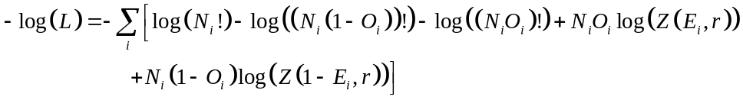

where Z(x,r) is a robustifying function with parameter r>0 (to prevent division by zero errors), defined as

And the binomial-approx likelihood is:

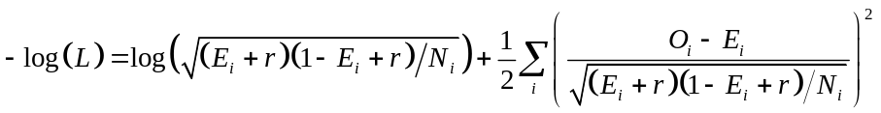

Here r is a non-negative robustifying constant (a nonzero value of r is recommended if only to prevent division by zero errors).

This likelihood corresponds to the assumption that, for each observation in each year, a simple random sample of size N_{i} was taken from the partition and that the observation value was the proportion of fish in the sample who migrated/matured/etc.

Likelihoods for absolute index data

Let O be the observations for a single year in an time series of absolute indices, expressed as a vector of n elements (with n=1 for abundance indices, n>1 for proportions mature or proportions migrating); let E be the corresponding fitted values; express the variability of each observation O_{i} in terms of its c.v. c_{i} (or in one case, its standard deviation s_{i}). Then you can use the following likelihoods, which are expressed on the objective-function scale
of -log(L):

- Normal
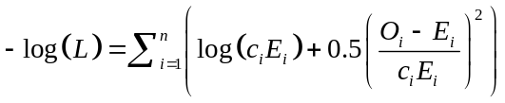

This reflects the distributional assumption that O_{i} has the normal distribution, with mean E_{i} and c.v. c_{i}.

- Normal parameterised by standard deviation rather than c.v.

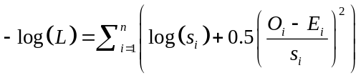

This reflects the distributional assumption that O_{i} has the normal distribution, with mean E_{i} and standard deviation s_{i}.

- Lognormal:

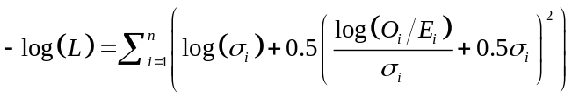

where .

This reflects the distributional assumptions that O_{i} has the lognormal distribution, that the mean of O_{i} is E_{i} and the c.v. of O_{i} is c_{i}.

- Normal-log

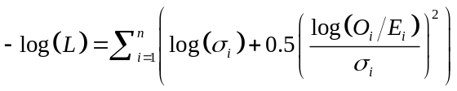

where .

This reflects the distributional assumption that log(O_{i}) has the normal distribution, that the mean of log(O_{i}) is log(E_{i}) and the c.v. of O_{i} is c_{i}.

We make the distinction between lognormal and normal-log because they represent subtly different assumptions. With the lognormal, O has mean E and hence the mean of log(O) is less than log(E): whereas with the normal-log, log(O) has mean log(E) and hence the mean of O is more than E.

Catchability coefficients q; likelihoods for relative index data

The log-likelihoods of relative observations depend on the error distribution and the way in which q’s are treated in the model. There are two approaches to modelling q’s:

- The q’s can be treated as ‘nuisance’ parameters. For each set of values of the free parameters, the model uses the values of the q’s which minimise the objective function. These optimal q’s are calculated algebraically (see Section 6.7.3). If one of the q’s falls outside the bounds specified by the user, it is set equal to the closest bound. This approach reduces the size of the parameter vector and hence should improve the performance of the estimation method. It is the default in SPM. However, it is not correct when calculating a sample from the posterior in a Bayesian analysis (except asymptotically, see Walters & Ludwig 1994) and we offer the following alternative;

- The q’s can be treated as ordinary free parameters.

For both options, we need to evaluate the contribution of O to the negative log-likelihood for a given value of q. Let O be the observations for a single year in an time series of relative indices, expressed as a vector of n elements (with n=1 for relative abundance indices, n>1 for relative numbers-at-age or at-size). Let E be the corresponding fitted values and q the catchability coefficients for the time series. It is possible for two or more time series collected in similar ways to use the same q. Each observation O_{i} varies about qE_{i} — express the variability of O_{i} in terms of its c.v. c_{i} (or in one case, its standard deviation s_{i}). Here are the likelihoods, which are expressed on the objective-function scale of -log(L):

- Normal

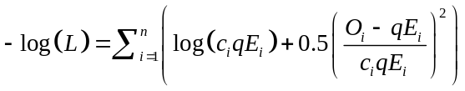

This reflects the distributional assumption that O_{i} has the normal distribution, with mean qE_{i} and c.v. c_{i}.

- Lognormal

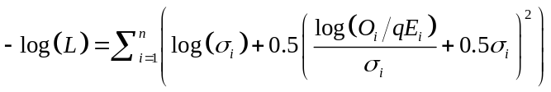

where .

This reflects the distributional assumptions that O_{i} has the lognormal distribution, that the mean of O_{i} is qE_{i} and the c.v. of O_{i} is c_{i}.

- Normal-log

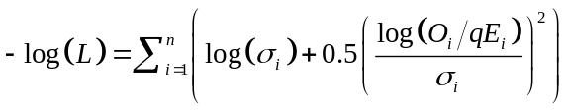

where .

This reflects the distributional assumption that log(O_{i}) has the normal distribution, that the mean of log(O_{i}) is log(qE_{i}) and the c.v. of O_{i} is c_{i}.

- Robustified lognormal

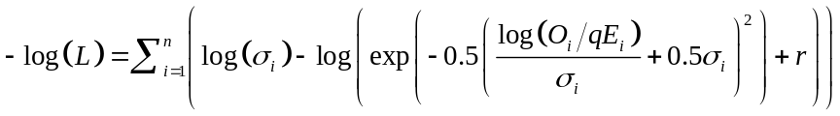

where and r is a robustifying constant.

This modification to the lognormal is intended to reduce the influence of outliers, and is analogous to the robustified normal distributions of Fournier et al. (1990). We recommend r=0.01, though smaller values (0.001, 0.0001, …) could be used for a lesser robustifying effect. We believe that this likelihood may be most appropriate for relative numbers-at-age or at-size but not for relative abundance indices (its effects are equivalent to dropping observations with large normalised residuals, which may be undesirable for abundance data).

Optionally, a curvature parameter, b, can be used for relative-abundance or relative numbers at observations. This is intended for modelling hyper-depletion or hyper-stability in CPUE (see Harley et al. 2001). In this case the expected value of Oi is assumed to be qE_{i}^{1/b}. [In earlier versions of SPM this expected value was assumed to be q(E_{i}/max(E))^{1/b}, which reduces correlation between q and b. However, this had the unforeseen disadvantage of modifying the interpretation of the prior on q in Bayesian estimation. This option is still available (see command @q_type) but is not recommended.] Also note that if you wish to estimate the curvature parameter, then the q’s cannot be treated as ‘nuisance’ parameters — you will need to set @q_method=free.

Process error

In a likelihood-based or Bayesian analysis, you can specify a ‘process error’ for each set of observations. This has the effect of increasing the error in the data (by increasing c.v.s or standard deviations, or decreasing effective sample sizes), and hence of decreasing the weight given to the data in the fitting process.

For data where the likelihood is parameterised by the c.v., you can specify the process error for a given set of observations as a c.v., in which case all the c.v.s c_{i} are changed to

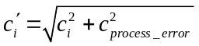.

Similarly, if the likelihood is parameterised by the standard deviation,

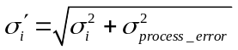,

and by the effective sample size,

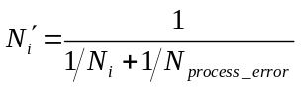.

In all three cases, the process error has more effect on small errors than on large ones. Be clear that a large N_{process_error} means a small process error.

In tag-recapture observations, you can specify the process error through the use of a dispersion parameter ø. Here, the tag-recapture log-likelihood is modified by multiplying by 1/ø. Note that values of ø<1 are allowed, but such values would result in an increase in the effective sample size and a resulting increase of the weight given to the tag-recapture observations in the fitting process. This is probably not sensible in most applications.

SPM allows you to estimate process error, though whether you should is another matter. If you want to make several sets of observations share the same process error, use the same subcommand in the estimate block (see Section 6.2).

Calculating nuisance q’s

This section describes the equations used to calculate nuisance catchability coefficients q’s (see Section 6.7.1). From the user’s point of view, the essence is that you can use nuisance q’s in the following situations:

- With maximum likelihood.

- With Bayesian estimation, providing that your prior on the q is one of the following:
- Uniform
- Uniform-log
- Lognormal with observations distributed lognormal, robustified lognormal, or normal-log.

The equations used for calculating nuisance qs in maximum likelihood or Bayesian analysis are indexed in Table 2.

Table 2: Equations used to calculate nuisance q’s. (*=no analytic solution found.)
Distribution of | Maximum | Bayesian with specified prior on q
observations | likelihood | Uniform | Uniform-log | Normal | Lognormal
Normal | (1) | (1) | (4) | * | *
Lognormal | (2) | (2) | (5) | * | (6)
Normal-log | (3) | (3) | (7) | * | (8)

Note that q’s are calculated for robustified lognormal likelihoods as if they were ordinary lognormal likelihoods.

The equations and their derivations follow. Let 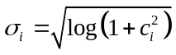throughout, and let n be the number of observations in the time series. The case of multiple time series sharing the same q, and the modifications required for the assumption of curvature, are addressed at the end of this subsection.

First, consider maximum likelihood estimation. When the (O_{i}) are assumed to be normally distributed,

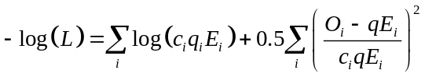

The value of q which minimises the objective function is found by solving 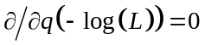.

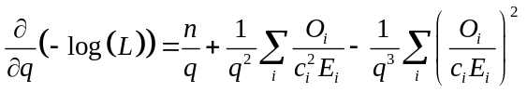

hence

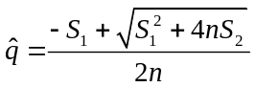 (1)

where 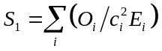 and 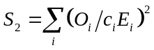.

When the (O_{i}) are assumed to be lognormally distributed,

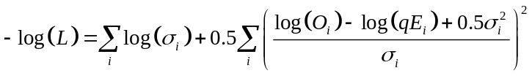,

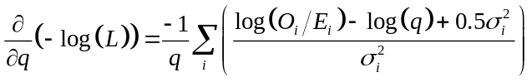,

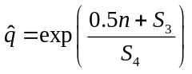 (2)

where 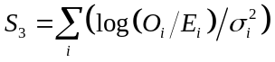 and 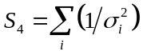.

When the (O_{i}) are assumed to be distributed normal-log, the equations are similar,

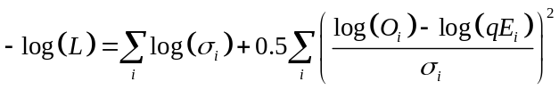,

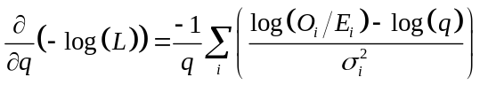,

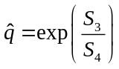 (3)

Next consider Bayesian estimation, where we must also specify a prior for q.

The effects of the prior on the equations are to replace likelihood L by posterior P throughout, to add -log(π(q)) to the equation for -log(P) and 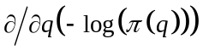to the equation for 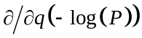.

This last term is 0 for a uniform prior on q, 1/q for a log-uniform prior, 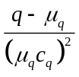for a normal prior, and 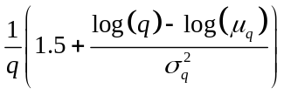 for a lognormal prior,

where μ_{q} and c_{q} are the mean and c.v. of the prior on q and 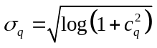. Clearly, if the prior is uniform, the equation for is the same as for maximum likelihood estimation.

When the (O_{i}) are assumed to be normally distributed and the prior is log-uniform, equation (1) becomes

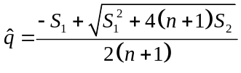 (4)

but we cannot solve for with either a normal or lognormal prior.

When the O_{i} are assumed to be lognormally distributed and the prior is log-uniform, equation (2) becomes

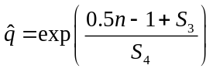 (5)

and if the prior is lognormal,

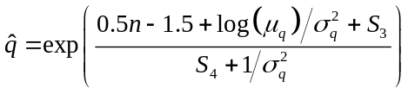, (6)

but we cannot solve for with a normal prior.

When the (O_{i}) are assumed to be distributed normal-log and the prior is log-uniform,

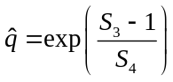 (7)

and if the prior is lognormal,

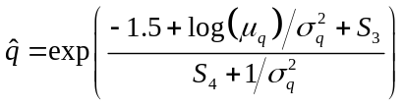 (8)

but again we cannot solve for with a normal prior.

The above equations have been written for a single time series (O_{i}) and no curvature assumption. Suppose now that there are m time series, all with the same q, and all with the same error distribution. This has little effect on the above equations. All we need to do is to extend the summations in S₁, S₂, S₃, and S₄ over all observations in the m time series, and let n=Σ_{j} n_{j}. To adjust the equations to allow for curvature we need only replace E_{i} by E_{i}^{1/b} or, if the original curvature assumption is used (see Section 6.7.1), by (E_{i}/max(E))^{1/b}.

Priors

In a Bayesian analysis, you need to give a prior for every free parameter. There are no defaults.

Note that when some of these priors are parameterised in terms of mean, c.v., and standard deviation, these refer to the parameters of the distribution before bounds are applied. The moments of the prior after the bounds are applied may differ.

For a single scalar parameter p, you can choose between the following priors (expressed in terms of their contribution to the objective function):

- Uniform,

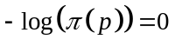.

- Uniform-log (i.e., log(p) ~ uniform),

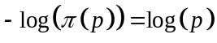.

- Normal with mean μ and c.v. c,

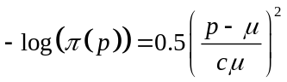.

- Normal with mean μ and standard deviation σ,

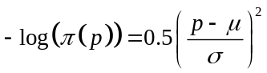.

- Lognormal with mean μ and c.v. c. 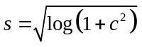, is the standard deviation of log(p).

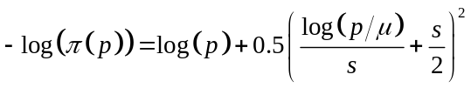.

- Normal-log with log(p) having mean m and standard deviation s,

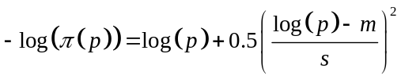.

- Beta with mean μ and standard deviation σ, and range parameters A and B.

,

where 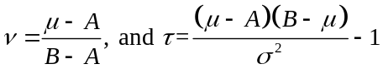

and then 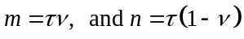. Note that the beta prior is undefined when 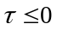.

Vectors of parameters can be independently (but not necessarily identically) distributed according to any of the above forms, in which case the joint negative-log-prior for the vector is the sum of the negative-log-priors of the components. Values of each parameter need to be specified for each element of the vector.

In addition, for a vector p of n identically distributed parameters (for example, YCS) the following priors are allowed:

- Multivariate normal from a stationary AR(1) process with parameters

μ=E(p_{i}), σ=sqrt(Var(p_{i})), and ρ=Cor(p_{i}, p_{i+1}),

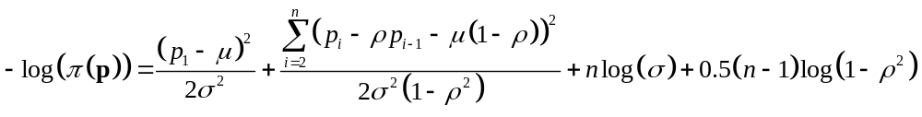
In other words, there are (n-1) i.i.d. normal variates z_{i} with mean μ and variance σ², such that 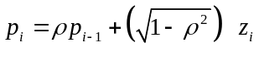.

If ρ=0, then the p_{i}’s are i.i.d. normal.

- Multivariate normal-log, where log(p) forms a stationary AR(1) process as per 1. above, with parameters

m=E(log(p_{i})), s=sqrt(Var(log(p_{i}))), and r=Cor(log(p_{i}), log(p_{i+1})),

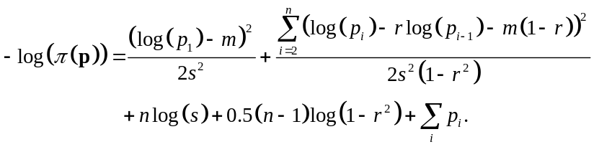

- Multivariate normal-log with mean 1, where E(p_{i})=1 and log(p) forms a stationary AR(1) process as for the multivariate normal above, with parameters

s=sqrt(Var(log(p_{i}))) and r=Cor(log(p_{i}), log(p_{i+1})),
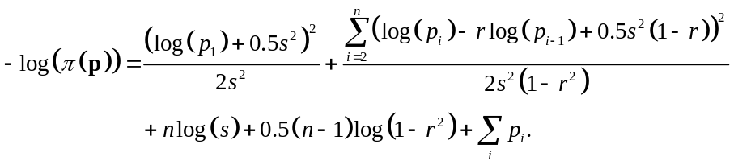
(i.e., m=-0.5s²)

Penalties

Penalties can be added to any objective function. You will usually want to use a catch limit penalty for each fishery to ensure that the exploitation rate constraints on your fisheries are not breached (otherwise there is nothing to prevent the model from having abundances so low that the recorded catches could not have been taken). A vector average penalty to force YCS to average to 1 is also very common.

For most penalties, you need to specify a multiplier, and the objective function is increased by this multiplier times the penalty as described below. In some cases you will want to make the multiplier quite large, so as to prohibit some model behaviour. For penalties without multipliers, the objective function is just increased by the value of the penalty. So far, the penalties implemented in SPM are:

1. Selectivity smoothing penalty:

Applied to an allvalues or allvalues_bounded selectivity parameter (Section 5.6). Sum of squares of rth differences. This encourages the selectivity to be like a polynomial of degree(r-1). For compatibility with previous NIWA software, you can choose to exclude indices outside a given set of bounds (these indices are ignored during differencing).

2. Catch limit penalty:

Sum of squares of (actual catch less specified catch), optionally on a log scale, for a single fishery. These are intended to avoid parameter values that cause the specified fishing pressure limits to be exceeded. The penalty is only applied if some fishing pressure limit has been exceeded (since inaccuracy in the iterative solution for F in the Baranov equation leads to actual catches slightly less than specified, and you don’t want to penalise that).

3. Vector average penalty:

Applied to a vector parameter. Square of (mean(vector)-k), or of (mean(log(vector))-l), or of (log(mean(vector)/m)). Encourages the vector to average arithmetically to k or m, or geometrically to exp(l). Typically used for YCS with k=1 or m=1 or l=0, to encourage the YCS to centre on 1.

4. Vector smoothing penalty:

Applied to a vector parameter. Sum of squares of rth differences. This encourages the vector to be like a polynomial of degree (r-1). Note a range of the vector to be “smoothed” can be specified (and if not, the smoother is applied to the entire vector), but this must be specified by an index of the vector and must be between 1 and the length of the vector, inclusive.

5. Element difference penalty:

Applied to two vector parameters. Square of (vector₁[i]-vector₂[i]). Encourages the ith elements of the two vectors to be equal.

6. YCS difference penalty:

Applied to the YCS of two different stocks. Squared difference between the YCS values for a given year in the two stocks. Used to encourage the two stocks to have the same YCS for that year. If the Haist YCS parameterisation is used, then the penalty applies to the YCS (as one would expect) and not the Y’s.

7. Similar qs penalty:

Applied to two catchabilities q (Section 6.7.1). Square of (log(q₁)-log(q₂)). This is intended to encourage q₁ and q₂ to be similar, perhaps because they belong to observations collected in similar ways.

8. Ratio qs penalty:

Applied to the ratio, q₁/q₂, of two catchabilities, and intended to encourage this ratio to be near μ (Section Error: Reference source not found). The penalty is defined as a lognormal with mean μ and c.v. c:

penalty 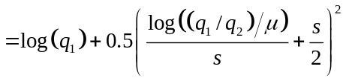,
where s is the standard deviation of log(q₁/q₂), so .

9. Selectivity comparison penalty:

Applied to two selectivity parameters (Section 5.6). Sum of squares of max(selectivity₁-selectivity₂,0). Encourages selectivity₁ to be at or below selectivity₂. Typically selectivity₁ is a selectivity for males, selectivity₂ is a selectivity for females. This is intended to encourage female selectivities to be greater than those of males at the same age/size. For compatibility with previous NIWA software, you can choose to exclude indices outside a given set of bounds (these indices are dropped off before comparing). Note that this penalty may not be applied to size-based selectivitys in age-based models.

10. Selectivity difference penalty:

Applied to two selectivity parameters (Section 5.6). Square of (selectivity₁-selectivity₂) for a single size or age class. This is intended to encourage the two selectivitys to take the same value for that class. Note that this penalty may not be applied to size-based selectivitys in age-based models.

11. Fish-tagged penalty:

Applied to a specific tagging episode. Square of min(0, number of fish meant to be tagged less number of fish actually tagged). Intended to discourage parameter values which lead to not enough fish being present at the tagging episode. Considering that the tonnage of fish actually tagged is usually very small, this penalty will generally be zero.

Ageing error

In age-based models, we allow ageing error in at-age observations to be modelled explicitly. After E (expected) values are calculated for at-age observations, misclassification rates are applied to them, which has the effect of ‘smearing’ the age frequencies. The resulting ‘smeared’ age frequencies are used in calculating the objective function.

Ageing error is optional, and if it is used, it may be omitted for any individual time series. However, SPM does not yet implement changes in ageing error over time, or different ageing error regimes for different time series.

The ageing error models implemented in SPM are as follows:

1. Off by one:

Proportion p₁ of fish of each age a are misclassified as age a-1 and proportion p₂ are misclassified as age a+1. Fish of age a < k are not misclassified. If there is no plus group in the population model, then proportion p₂ fish of the oldest age class will ‘fall off the edge’ and disappear.

2. Normal:

Fish of age a are classified as ages which are normally distributed with mean a and constant c.v. c. As above, if there is no plus group in the population model, some fish of the older age classes may disappear. If c is high enough, some fish of the younger age classes may ‘fall off the other edge’ too.

3. Misclassification matrix:

A complete misclassification matrix M is provided, such that M_{ij} is the probability that a fish of age i will be classified as age j. Rows need not sum to 1, but a warning will be issued if they don’t.

Note that the expected values (fits) reported by SPM for an individual time series with ageing error, have had the ageing error applied.

Residuals

SPM can generate three kinds of residuals, (1) the usual residuals (i.e., observed less fitted), (2) Pearson residuals, and (3) normalised residuals. There are defined in SPM as,

Let O be an observation and F the corresponding fit (=qE for relative observations), then:

- Residuals are defined as (O-F).

- Pearson residuals attempt to express the residual relative to the variability of the observation, and are defined as (O-F)/std.dev.(O), where std.dev.(O) is calculated as,

  - F × cv for normal, lognormal, robustified lognormal, and normal-log error distributions.

  - s for normal-by-standard deviation error distributions.

  - 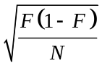for multinomial or binomial likelihoods (regardless of the robustifying constant).

  - 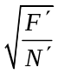 for Fournier likelihoods (where 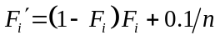 and , on the basis that they would be equivalent to a multivariate normal with this standard deviation if the final (+0.01) term was omitted.)

  - 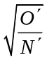for Coleraine error likelihoods (similarly).

- Normalised residuals attempt to express the residual on a standard normal scale, and are defined as,

- Equal to the Pearson residuals for normal error distributions.
- (log(O/F)+0.5σ²)/σ for lognormal (including robustified lognormal) error distributions, where 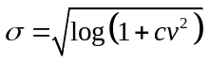.
- (log(O/F)/σ for normal-log error distributions, again with .
- And are otherwise undefined.

The output section

This section contains three main topics.

- Section 7.1 describes the printouts from SPM, which are dumped to standard output (and can be redirected to a file, and imported into R using the functions described in Section 12).

- Section 7.2 describes projections in SPM.

- Sections Error: Reference source not found and Error: Reference source not found describe yield calculations in SPM, including deterministic MSY, various yield per recruit statistics, MCY, CAY, and CSP.

Information about MCMC output file formats is given earlier in Section 3.1.

Printouts from SPM

SPM prints out a bunch of different things to standard output. Some of them appear automatically, others you have to ask for. We should emphasize that the exact content of these outputs can be expected to change without notice. The best way to find out exactly what SPM prints is to run it and find out.

The main types of printouts are:

- An initial header, giving the command by which SPM was invoked, the date, the version numbers of the key source files used to build that copy of SPM, the version number of SPM itself, user login, and machine name.

- The names of any additional output files that were generated, such as MCMC output dumps.

- The results of the particular task asked for. If you run the model or estimate the parameters (SPM -e, -E, -r), SPM will print out the free parameters, the objective function and its components. If you profile some parameters (SPM -p), SPM will print out the objective function value and the free parameter estimates, for each value of each profiled parameter. If you are doing MCMC (SPM -m), SPM will print the initial point estimate, the approximate covariance matrix, the lower and upper bounds on the free parameters during MCMC, the start of the chain, and any changes in step size, etc.

- Printouts from the population section of SPM. You can ask for printouts of the requests sent to the population section by the estimation and output sections and the corresponding results. You can request printouts of the initial state, the final state, the state after every year or every step. These are mostly useful in debugging, i.e., you can inspect them to figure out whether the population dynamics are what was intended. The most important of these printouts is ‘population_section’ which gives a text explanation of how SPM interprets the population section in the population.SPM file — always look at this printout when you develop a model to ensure that you have correctly specified the model.

- These population printouts only appear if you ask for them in the output.SPM file. You may want to use the -q switch to suppress these printouts, because a major job can generate a huge amount of them. (You can achieve the same result by turning all these requests off in output.SPM.)

- Printouts from the estimation section of SPM. You can ask SPM to print out the parameter lists generated from your population.SPM and estimation.SPM files, a good way of checking that your files were read as intended. You can ask for fits, residuals, and standardised residuals. For debugging purposes, you can ask SPM to print out the objective, parameters, or fits every time the objective function is calculated (so they are printed at each step of a minimization). You can ask for a text explanation of how SPM thinks your estimation section works — always look at this printout when you develop a model. Also check out the list of parameters that were never accessed by SPM. Presence of a parameter on the list may indicate that the parameter name was spelt incorrectly. (Or it may just mean that the parameter is not used for the task you were doing, for example max_iters is not used by SPM -r). All these estimation printouts only appear if you ask for them in the output.SPM file.

- Output quantities. These are model outputs calculated from the parameters. They can be produced for any set of free parameters, whether it comes from a model run (SPM -r), a point estimate (-e, -E), for values sampled from a Bayesian posterior (-v), or for projections (-P). The output quantities SPM can produce are listed in Section Error: Reference source not found. Output quantities only appear if you ask for them in the output.SPM file.

Projections

Projection is the process of running the model forwards into the future, using randomised recruitments and hypothetical catches. SPM does this in three situations:

- Calculation of current annual yield (CAY) (see Section Error: Reference source not found).

- Calculation of current surplus production (CSP) (see Section Error: Reference source not found).

- Producing projected fishery performance estimators (FPIs), such as stock risk, or expected biomass in 5 years time.

All three situations use the same method for generating projections, which is described in Section 7.2.1. The calculation of FPIs is discussed in Section Error: Reference source not found.

Carrying out projections

Projections can either be point-based (i.e., using a single point estimate of the free parameters), or sample-based (using a sample from the posterior distribution, typically generated by MCMC using SPM -m, or SPM -C).

For point-based projections SPM does a large number of simulations, each using the same parameters. The simulations will differ only in terms of the randomised recruitments. Year class strengths will be randomised for the cohorts which will recruit in the ‘projection period’, i.e., the years current+1 to final. You can also choose to randomise YCS for cohorts which have recently recruited (perhaps because there is no information about the abundance of these cohorts). You can also modify the YCS values by an arbitrary multiplier. If there is an explicit climate-recruitment relationship, SPM uses the climate data T up until the last year for which it is provided (which could be as late as the assessment year, or might even be a forecast for the future) and then randomises T for years after that.

For sample-based projections SPM does one simulation for each posterior sample point. Each simulation will use a different set of parameters and a different set of randomised recruitments. YCS and T’s will be randomised as above (the only difference is that the user might not need to randomise some recent YCS if their uncertainty was incorporated in the posterior distribution).

In either case, the ‘projected expectation’ of a quantity refers to an average over all the simulations.

When doing projections so as to calculate fishery performance indicators, you need to specify future catches or future mortalities (either Baranov or non-Baranov) for each fishery in each year. SPM does not implement adaptive harvest strategies in projections. If you want to assess a different catch scenario, you need to change the future catches in the data file and rerun the program.

You can choose between four methods of randomising the YCS, :

- Lognormal: The randomised YCS are lognormally distributed, with mean 1, and specified standard deviation and autocorrelation on the log-scale. YCS_{i}=exp(X_{i}), where (X_{i}) are generated as a Gaussian AR(1) process with standard deviation σ_{R} and mean-0.5σ_{R}² (so that the mean of YCS_{i} is 1), and autocorrelation ρ. Set ρ=0, the default, if you don’t want autocorrelation. If the randomised YCS are modified by an arbitrary multiplier, then the only change is that X_{i} will have mean µ, where µ is the recruitment multiplier.

- Lognormal-empirical: The randomised YCS are lognormally distributed as per the lognormal method above. The only difference is that the standard deviation parameter is chosen to give variability equal to that of the estimated YCS. SPM uses σ_{R} as the standard deviation of the log of the estimated YCS. Optionally, the calculation of σ_{R} can be based on a sub-range of the estimated YCS (since not all YCS are well estimated and some may even be fixed). As for the lognormal method, the randomised YCS can be multiplied by an arbitrary multiplier, with the standard deviation calculated as described.

- Empirical: The randomised YCS are resampled from the estimated YCS. Again, they can optionally be resampled from a sub-range of the estimated YCS. If the randomised YCS are modified by an arbitrary multiplier, then the each of the randomised YCS are multiplied by the recruitment multiplier.

- None: All the randomised YCS are 1, but if modified by an arbitrary multiplier, then the YCS will all equal the recruitment multiplier. Used for deterministic projections only.

If a nonzero autocorrelation parameter ρ is used with lognormal or lognormal-empirical randomisations, then the randomised values must depend on the last fixed value YCS_{f}. This can get a bit ‘messy’.

Let 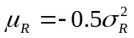,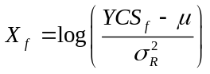 and (Z_{i}) be standard normal random deviates, then

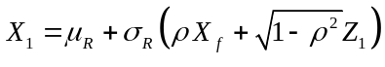, and 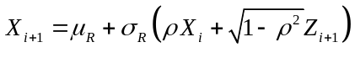.

Now if the user specifies a very small or zero σ_{R}, probably in an effort to generate constant YCS_{i}=1, and a nonzero ρ, and YCS_{f} is substantially different from 1, then the above formula gives an unexpected result, the YCS_{i} are not 1, but decay exponentially from YCS_{f} towards 1. This is because under these assumptions the value of YCS_{f} is highly implausible. SPM avoids this situation by erroring out if |X_{f}|>5 with “last non-random year has implausible value”. The user can fix the error by setting ρ=0, increasing σ_{R}, or turning off randomisation (using method none).

We provide the same four methods for randomising the Ts associated with a climate-recruit relationship (see Section 5.3.2). The only difference is that the randomised Ts need not come from a distribution with mean 1. For lognormal randomisation, or no randomisation, the mean of the Ts is specified by the user. For lognormal-empirical randomisation, it is the mean of the estimated Ts.

So, to define the method of doing projections, you need to tell SPM the following:

- If projections are point based, the number of projections to be done.

- Which is the first year for which YCS are randomised? The default is (current-y_{enter}+1), which is the first year for which YCS are not provided. But you can specify an earlier year if they want to randomise abundance of some recently recruited cohorts. (Note that this is the year in which the fish spawn, not the year in which they recruit.)

- Future catches or future mortalities (either Baranov or non-Baranov) for each fishery in each projected year. (This is only necessary for producing FPIs, not for CAY or CSP.)

- The methods used to randomise YCS and Ts, and the relevant parameters.

Of the above, only the first point is specified in the output.SPM file. All the others are in population.SPM since they relate to the recruitment variability of the population, and the catches.

The population.SPM file

The population parameters are specified in the population.SPM file. See Section 5 for information about the population section, and Section 3.4 for instructions on writing a SPM data file.

Parsing an external file
@include_file Include an external file into the population.SPM file
Effects Defines an external file which is parsed while the population.SPM file is parsed by SPM. Any commands and subcommands in the external file are parsed as if they were a part of the population.SPM file.

Defining the spatial structure of the model
@spatial_structure Block command to define the spatial structure of the model
Conditions Must be supplied
Effects Defines any following subcommands as @spatial_structure subcommands.
nrows The number of rows in the matrix describing the spatial structure
Command spatial_structure
Type Integer
Effects Defines the number of rows in the matrix defining the spatial structure
ncols The number of columns in the matrix describing the spatial structure
Command spatial_structure
Type Integer
Effects Defines the number of columns in the matrix defining the spatial structure

Defining the population structure of the model
@population_structure Block command to define the population structure of the model within each spatial cell
Conditions Must be supplied
Effects Defines any following subcommands as @population_structure subcommands.
categories The names of the categories that describe the rows of the population matrix
Command population_structure
Type String vector
Effects The number of rows in the population matrix are defined by the number of categories labels supplied.
min_age The minimum age of individuals within the population structure
Command population_structure
Type Integer
Effects The number of columns in the population matrix are defined by the range of min_age to max_age.
max_age The maximum age of individuals within the population structure
Command population_structure
Type Integer
Effects The number of columns in the population matrix are defined by the range of min_age to max_age.
plus_group Should a plus age or size group be used?
Command population_structure
Type Switch
Default True (use a plus group)
Effects Defines the last age class as a plus group.

Initialising the model starting state and defining the model run period
@initialisation Block command to define model years and burn-in period for initialising the model
Conditions Must be supplied
Effects Defines any following subcommands as @initialisation subcommands.
initial_years The number of years that the model is run, without any stock-recruit relationship, to initialise the model
Command initialisation
Type Integer
Effects Runs the model for initial_years, from a starting state where every element in the model is initialised as zero.
start_year Defines the label of the first year (after initial_years) of the model
Command initialisation
Type Integer
run_years Defines number of years to run the model after initial_years.
Command initialisation
Type Integer
Notes The ith model year is labelled as start_year + i - 1
projection_years Defines number of years in which to run the model when undertaking projections.
Command initialisation
Type Integer
Notes The ith model projection year is labelled as start_year + run_years + i - 1

Defining the annual cycle
@annual_cycle Block command to define number of time-steps that occur within each annual cycle
Conditions Must be supplied
Effects Defines any following subcommands as @annual_cycle subcommands.
time_steps The number of time-steps to apply in each year of the annual cycle
Command annual_cycle
Type Integer

Defining the time steps
@time_step Block command to define the processes that occur in a particular time-step
Conditions Must be supplied for each time-step in annual_cycle
Label The numeric label of the time-step (i.e., from 1 to annual_cycle.time_steps)
Effects Defines any following subcommands as @time_step subcommands.
population_processes The labels of the population_processes to apply within this time-step
Command time_step
Type String vector of length at least one
Value Labels must be defined as a label of @population_processes
Notes Any number of processes can be supplied, and these are carried out within the time step in the order supplied. The labels need not be unique.
movement_processes The labels of the movement_processes to apply within this time-step
Command time_step
Type String vector of length at least one
Value Labels must be defined as a label of @movement_processes
Notes Any number of processes can be supplied, and these are carried out within the time step in the order supplied. The labels need not be unique.

Defining the population processes
@population_process Block command to define a population process
Label The label of the process
Effects Defines any following subcommands as @population_process subcommands.
Notes The label must be unique, and cannot be the same as an @movement_process label.
type The type of population-process
Command population_process
Type String
Value Must be one of age, recruitment, natural_mortality, event_mortality, or category_transition.
Notes Depending on the type, different subcommands may be required.
categories The categories over which the population process applies
Command population_process
Type String vector of length in the range from one to the number of elements in @population_structure.categories
Value Elements must be one of @population_structure.categories

If type=’ageing’,
depends_on_layer Does the population process depend on a layer?
Command population_process
Type Switch (true/false)
Effects If true, then the population process must depend on the values of a layer. If so, the layer and method must also be specified
Value Cannot be true for an ageing, natural_mortality, event_mortality, or category_transition event.
method Method of dependence of the population process on a layer?
Command population_process
Type Switch (true/false)
Effects If true, then the number of recruits must depend on the values of a layer. If so, the layer and method must also be specified
Value Currently only ‘uniform’ is allowed for @population_process.type=recruitment
layer Dependence layer?
Command population_process
Type String
Value One of the labels of @layer

If type=’recruitment’
proportions The relative proportion of individuals to recruit to each category
Command population_process
Type Estimable vector of length equal to number of elements in @population_process.categories
Value Elements must sum to 1. If not, they will be rescaled proportionally to sum to one
R0 Number of recruits
Command population_process
Type Estimable
Value The number of recruits must be a positive (≥0) value
age Ages to recruit to
Command population_process
Type Constant vector of length equal to the number of elements in @population_process.categories
Value Elements must be within the range min_age to max_age
steepness Steepness parameter of the stock-recruitment relationship
Command population_process
Type Estimable
Effects Defines the steepness parameter h of the Beverton-Holt stock-recruitment relationship
layer_min Minimum value of layer?
Command population_process
Type Constant
Value A value that values of the layer must be greater than or equal to so-as to attract recruitment
layer_max Minimum value of layer?
Command population_process
Type Constant
Value A value that values of the layer must be less than or equal to so-as to attract recruitment
randomisation_method Randomisation method for recruitment variability in projections
Command population_process
Type String
Effects Defines the randomisation method to use in projections. Should be lognormal, lognormal-empirical, empirical or none.
sigma_r Standard deviation on the log scale of randomised YCS
Command population_process
Conditions Only used if randomisation_method=lognormal or lognormal-empirical.
Type Constant
Effects Defines the standard deviation of log-YCS (σ_{r}) parameter for use in projections.
rho Lag-1 log-scale autocorrelation of randomised YCS
Command population_process
Conditions Only used if randomisation_method=lognormal or lognormal-empirical.
Type Constant
Default 0 (i.e., no autocorrelation)
Effects rho defines the autocorrelation of log-YCS (ρ) parameter for use in projections
year_range Year range from which randomised YCS are resampled
Command population_process
Conditions Only used if randomisation_method=empirical or lognormal-empirical.
Type Constant vector
Default All years in the original YCS
Effects Defines the year range from which the resampling (nonparametric bootstrap) methods draw their samples, in projections.
Notes Provide just two numbers, the first and last years, for each parameter.
The program resamples YCS from these ranges of years (inclusive)
recruitment_multipler Multiply the randomised YCS by an arbitrary multiplier
Command population_process
Type Constant
Default 1
Effects The recruitment multiplier modifies the randomised YCS by an arbitrary factor in projections. See Section 7.2.1 for detail.
depends_on_layer Does the population process depend on a layer?
Command population_process
Type Switch (true/false)
Effects If true, then the population process must depend on the values of a layer. If so, the layer and method must also be specified
Value Cannot be true for an ageing, natural_mortality, fishing_mortality, or category_transition event.
method Method of dependence of the population process on a layer?
Command population_process
Type Switch (true/false)
Effects If true, then the number of recruits must depend on the values of a layer. If so, the layer and method must also be specified
Value Currently only ‘uniform’ is allowed for @population_process.type=recruitment
layer Dependence layer?
Command population_process
Type String
Value One of the labels of @layer

If type=’natural_mortality’
M The instantaneous rate of natural mortality to apply
Command population_process
Type Estimable vector of length equal to number of elements in @population_process.categories
Value Elements must be greater than 0 and less than 5
selectivities The selectivities to apply to each category when applying natural mortality
Command population_process
Type String vector of length equal to the number of elements in @population_process.categories
Value Elements must be a valid selectivity label from @selectivity
depends_on_layer Does the population process depend on a layer?
Command population_process
Type Switch (true/false)
Effects If true, then the population process must depend on the values of a layer. If so, the layer and method must also be specified
Value Cannot be true for an ageing, natural_mortality, fishing_mortality, or category_transition event.
method Method of dependence of the population process on a layer?
Command population_process
Type Switch (true/false)
Effects If true, then the number of recruits must depend on the values of a layer. If so, the layer and method must also be specified
Value Currently only ‘uniform’ is allowed for @population_process.type=recruitment
layer Dependence layer?
Command population_process
Type String
Value One of the labels of @layer

If type=’ event_mortality’
year The years in which to apply the event mortality
Command population_process
Type Vector of integers
Value Must be years after the initialisation period
Umax The maximum exploitation rate in any year from the event mortality
Command population_process
Type Constant
Value Must be a value greater than 0 and less than 1.0
layers The amount to be removed for each year
Command population_process
Type Constant
Value One layer must be defined for each year in @population_process.year
Effects SPM removes the amount defined in each layer in each year according to the selectivities.
selectivity The selectivity to apply
Command population_process
Type String
Value Must be a valid selectivity label from @selectivity

If type=’category_transition’
from The category (row) from which to shift individuals
Command population_process
Type String
Value Element must be a label from @population_structure.categories
to The category (row) to which to shift individuals
Command population_process
Type String
Value Element must be a label from @population_structure.categories
proportion The multiplier of proportions of individuals in each cell to shift
Command population_process
Type Estimable
Value Must be between 0 and 1
selectivity The selectivity to apply when calculating proportions to shift
Command population_process
Type String
Value Must be a valid selectivity label from @selectivity

Defining movement processes
@movement_process Block command to define a movement process
Label The label of the process
Effects Defines any following subcommands as @movement_process subcommands.
Notes The label must be unique, and cannot be the same as an @population_process label.
method The method by which individuals are moved
Command movement_process
Type String
Effects Defines the method for a movement process
Value One of square_uniform, square_density_independent, square_density_dependent, hex_uniform, hex_density_independent, hex_density_dependent, or directed.

If method= square_uniform, square_density_independent, square_density_dependent, hex_uniform, hex_density_independent, hex_density_dependent

proportion The multiplier of proportions of individuals in each cell to move
Command movement_process
Type Estimable
Value Must be between 0 and 1
categories The categories over which the movement process applies
Command movement_process
Type String vector of length in the range from one to the number of elements in @population_structure.categories
Value Elements must be one of @population_structure.categories
selectivities The selectivities to apply to each category when applying movement
Command movement_process
Type String vector of length equal to the number of elements in @population_process.categories
Value Elements must be a valid selectivity label from @selectivity
depends_on_layer Does the movement process depend on a layer?
Command movement_process
Type Switch (true/false)
Effects If true, then the movement process must depend on the values of a layer. If so, the layer must also be specified
Value Cannot be true for a square_uniform or hex_uniform event
layer Dependence layer?
Command movement_process
Type String
Value One of the labels of @layer

If method= directed
directed_process The labels of the directed_processes that define the preference function
Command movement_process
Type String vector
Value A vector of labels from @directed_process
Notes Must be of length at least one.

Defining preference functions for the directed movement process
@directed_process Block command to define the preference function parameters of a directed movement process
Label The label of the process
Effects Defines any following subcommands as @directed_process subcommands.
Notes The label must be unique.
type The type of preference function for the directed movement process
Command directed_process
Type String
Effects Defines the type (function) of a directed process
Value One of normal, double_normal, logistic, inverse_logistic, exponential, or threshold.
Notes Different subcommands are used for each type of directed process
alpha The value of α for each preference in the preference function
Command directed_process
Type Estimable
Effects Defines the value of alpha in the preference function
layer Dependence layer?
Command directed_process
Type String
Value One of the labels of @layer

If type=’normal’,
mu The value of μ in the normal preference function
Command directed_process
Type Estimable
Effects Defines the value of μ in the normal preference function
sigma The value of σ in the normal preference function
Command @directed_process
Type Estimable
Effects Defines the value of σ in the normal preference function

If type=’double_normal’,
mu The value of μ in the normal preference function
Command @directed_process
Type Estimable
Effects Defines the value of μ in the normal preference function
sigmaL The value of σ_{L} in the double_normal preference function
Command @directed_process
Type Estimable
Effects Defines the value of σ_{L} in the double_normal preference function
sigmaR The value of σ_{R} in the double_normal preference function
Command @directed_process
Type Estimable
Effects Defines the value of σ_{R} in the double_normal preference function

If type=’logistic’,
a50 The value of a₅₀ in the logistic preference function
Command @directed_process
Type Estimable
Effects Defines the value of a₅₀ in the logistic preference function
ato95 The value of a_{to95} in the logistic preference function
Command @directed_process
Type Estimable
Effects Defines the value of a_{to95} in the logistic preference function

If type=’inverse_logistic’,
a50 The value of a₅₀ in the inverse_logistic preference function
Command @directed_process
Type Estimable
Effects Defines the value of a₅₀ in the inverse_logistic preference function
ato95 The value of a_{to95} in the inverse_logistic preference function
Command @directed_process
Type Estimable
Effects Defines the value of a_{to95} in the inverse_logistic preference function

If type=’exponential’,
lambda The value of λ in the exponential preference function
Command @directed_process
Type Estimable
Effects Defines the value of λ in the exponential preference function

If type=’threshold’,
N The threshold abundance value in the threshold preference function
Command @directed_process
Type Estimable
Effects Defines the value of the threshold in the threshold preference function
lambda The value of λ in the threshold preference function
Command @directed_process
Type Estimable
Effects Defines the value of λ in the threshold preference function

Defining layers
@layer Block command to define an arbitrary layer
Label The label of the process
Conditions At least one layer (the base layer) must be defined)
Effects Defines any following subcommands as @layer subcommands
Notes The label must be unique.
type The type of layer
Command @layer
Type String
Value One of distance, abundance, numeric, or category.

If type=’distance’, other subcommands required

If type=’abundance’,
categories The categories over which the abundance is to be calculated
Command @layer
Type String vector of length in the range from one to the number of elements in @population_structure.categories
Value Elements must be one of @population_structure.categories
selectivities The selectivities to apply to each category when calculating abundance
Command @layer
Type String vector of length equal to the number of elements in @population_process.categories
Value Elements must be a valid selectivity label from @selectivity

If type=’numeric’,
normalise Should SPM normalise the layer before using it?
Command @layer
Type Switch
Default false
Effects Rescales the values in a layer so that the layer have a maximum value of 1
rowX The values of the layer in rowX
Command @layer
Type Constant vector of length @spatial_structure.ncols
Effects Defines the values of a the nth row of a layer
Notes You must supply subcommands rows1…rowsX, where X is equal to @spatial_structure.ncols, i.e., one row for each row in the spatial structure.
If type=’categorical’,
rowX The values of the layer in rowX
Command @layer
Type String vector of length @spatial_structure.ncols
Effects Defines the values of a the nth row of a layer
Notes You must supply subcommands rows1…rowsX, where X is equal to @spatial_structure.ncols, i.e., one row for each row in the spatial structure.

Defining selectivities
@selectivity Block command to define a selectivity
Label The label of the selectivity
Effects Defines any following subcommands as @selectivity subcommands.
Notes The label must be unique
type The type of selectivity
Command @selectivity
Type String
Value Must be one of constant, logistic, normal, or double_normal.
Notes Depending on the type, different subcommands may be required.

If type=’constant’,
c The constant value of the selectivity
Command @selectivity
Type Estimable
Effects Defines the value of c in the constant selectivity function

If type=’normal’,
mu The value of μ in the normal selectivity function
Command @selectivity
Type Estimable
Effects Defines the value of μ in the normal selectivity function
sigma The value of σ in the normal selectivity function
Command @selectivity
Type Estimable
Effects Defines the value of σ in the normal selectivity function

If type=’double_normal’,
mu The value of μ in the double normal selectivity function
Command @selectivity
Type Estimable
Effects Defines the value of μ in the double normal selectivity function
sigmaL The value of σ_{L} in the double_normal selectivity function
Command @selectivity
Type Estimable
Effects Defines the value of σ_{L} in the double_normal selectivity function
sigmaR The value of σ_{R} in the double_normal selectivity function
Command @selectivity
Type Estimable
Effects Defines the value of σ_{R} in the double_normal selectivity function

If type=’logistic’,
a50 The value of a₅₀ in the logistic selectivity function
Command @selectivity
Type Estimable
Effects Defines the value of a₅₀ in the logistic selectivity function
ato95 The value of a_{to95} in the logistic selectivity function
Command @selectivity
Type Estimable
Effects Defines the value of a_{to95} in the logistic selectivity function

The estimation.SPM file

Defining point estimation

The output.SPM file

Defining the printouts

Troubleshooting

Typical errors

SPM is a complex system providing many opportunities for error — either because your parameter files do not correctly specify your model, or because the model you tried to specify does not work. When in doubt, ask an experienced user. Debugging versions of SPM can be compiled that help to track down cryptic errors.

A short list of common errors that have been seen include;

Misspelt commands

If you misspell a command name in a parameter file, SPM will not read it. You might just as well have commented out the line. There are two possible consequences. If the command is compulsory, SPM will error out, complaining that it failed to find a parameter. If it is optional, SPM may run but do the wrong thing. One way to diagnose misspelt commands is using print.unused_parameters command in the input data file output.SPM (see Section 10.1). Note that commands are case sensitive.

No carriage return at the end of a parameter file

If you don’t put a carriage return after your last command, then that last command will not be read by SPM. You might just as well have commented out the last line. See above.

Misspelt arguments

Probably more likely to be picked up by SPM than misspelt commands, but still a potential problem. Note that almost all arguments are case sensitive.

Commented out command

If you have the following lines in an input data file, for example,
@size_based 0
@fishery trawl
selectivity trawl_sel
…
and you comment out the @fishery line, then this will effect the @size_based command. SPM will think @size_based is the beginning of a command block, because it now appears to have arguments (selectivity, etc.). Whereas in fact it is a single standalone command and should be treated as such. So the correct value of size_based will not be read. The fix for this one is to comment out or remove the entire @fishery block, and not just the first line.

No penalty on exceeding exploitation rate limits

Unless you use penalties, there is nothing to stop SPM from coming up with a parameter estimate under which there is not enough fish for the catches to be taken. You probably want to use a catch limit penalty for each fishery (see Section 6.7.5).

No penalty on year class strengths not averaging to 1

If you estimate recruitment with the standard or Haist YCS parameterisation, you may want to force year class strengths to average to 1. You need to use a vector average penalty (see Section 6.7.5) to do this. If you don’t, you may find that all your year class strengths are much more than 1 or much less than 1.

Proportions maturing specified as proportions mature

Be clear that the maturation rates supplied to SPM (when maturity is a partition character) are proportions of fish which become mature at each age, not proportions which are mature at each age,

Other errors

When SPM generates an error and the error message makes no sense to you, please let the SPM development team know. Even if you manage to fix the problem yourself, the development team may be able to implement a more helpful error message and make life easier for the next person to encounter the problem. Guidelines for reporting an error are given below in Section 11.4.

Some parameter values of functions or selectivities can result in either very large or very small numbers. These can, on occasion, generate internal numeric overflow errors within SPM. The most common cause of a “Betadiff error” (especially when accompanied by the message “Betadiff returned a NaN gradient for parameters …”) is a calculation that has resulted in an overflow error.

SPM does do some range checking of parameter values before attempting calculations, but there will be some instances where these checks are not adequate. For example, in the logistic selectivity, a very small value of a_{to95} (say, less than 0.2) can result in a very large value of 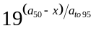 for some values of x. Without range checking, this would cause an overflow error. The work around to this type of error is to impose bounds on parameters that exclude the possibility of an overflow error.

However, errors that contain a ‘Betadiff error’ can also occur in other circumstances and typically mean that you have managed to generate an error that should have been trapped by SPM (for example, an array indexing error). If you manage to generate a ‘betadiff error’ please report it to the SPM development team (see Section 11.3), so that it can be checked and hopefully trapped with a more useful error message.

Reporting errors

If you wish to report a bug or problem with SPM, then please send a bug report to a.dunn@niwa.co.nz — after reading the guidelines below.

Use the text “SPM bug report” as the subject line in the email. Following these guidelines will assist the SPM development team identify, reproduce, and hopefully solve any reported bugs. It is helpful to be as specific as possible when describing the problem.

Note that SPM is distributed as unsupported software. We do not usually provide help for users of SPM outside of NIWA. However, the SPM development team may provide assistance to reasonable requests, but while we would appreciate being notified of any problems or errors in SPM, we may not be able to provide timely solutions.

Guidelines for reporting a bug in SPM

- Detail the version of SPM are you using? e.g., “SPM v2.07-2005/08/21 Microsoft Windows executable”

- What operating system/environment are you using? e.g., “IBM-PC Intel CPU running Microsoft Windows XP Release 2”.

- Give a brief one-line description of the problem, e.g., “a segmentation fault was reported” or “a betadiff error was reported”.

- If the problem is reproducible, please list the exact steps required to cause it, remembering to include the relevant SPM input parameter files. Also specify the exact command line arguments that were used, e.g., “Using the command SPM -e -q > logfile.out reports a segmentation fault. The files my-population.SPM, my-estimation.SPM, and my-output.SPM are attached.”

- If the problem is not reproducible (only happened once, or occasionally for no apparent reason), please describe the circumstances in which it occurred and the symptoms observed (but note it is much harder to reproduce and hence fix non-reproducible bugs, but if several reports are made over time that relate to the same thing, then this may help to track down the problem), e.g., “SPM crashed, but I cannot reproduce how I did it. It seemed to be related to a local network crash but I cannot be sure.”

- If the problem causes any error messages to appear, please give the exact text displayed, e.g., “Segmentation fault (core dumped)”

- Remember to attach all relevant input and output files so that the problem can be reproduced (it can helpful to compress these into a single file). Without these, it may not be possible to determine the cause of the problem.

Post-processing of SPM output

Documentation for R functions for reading/writing *.SPM files and extracting output to be inserted here.

Examples

Changes and Enhancements from previous versions

Introduction

The changes and enhancements between published versions SPM are detailed below. These include any incremental changes for unpublished version that may have been distributed in-between published versions. References for the published versions of SPM are Bull et al. (2002) for SPM v1.02-2002/10/21, Bull et al. (2003) for SPM v2.01-2003/08/01, Bull et al. (2004) for SPM v2.06-2004/09/26, and Bull at al. (2005) for v2.07-2005/08/21.

Acknowledgments

We thank Andreas Griewank and the other creators of the ADOL-C package — the basis of the Betadiff minimisation software underlying SPM — for freely supplying this product. Thanks also to Robert Davies for providing the newran random number generation library.

We thank Nokome Bently and Ian Ball for their work that led to the developement of this program. Andy McKenzie, Dave Gilbert, and Murray Smith provided helpful discussions with the authors that allowed this project to be completed. The SPM logo and icon were designed by Erika Mackay. The development of SPM was funded by the New Zealand Ministry of Fisheries and the New Zealand Foundation for Research, Science and Technology.

References

Index

ADOL-C 6
Ageing error 43
Misclassification matrix 44
Misclassification rates 43
Normal 44
Off-by-one 44
AUTODIF 6
Bash shell 6
Bayesian estimation
Acceptance probability 27
Adaptive proposal distribution 26
covariance_adjustment 26
Default proposal distribution 25
Fixed free parameters 27
Interruptions in the MCMC chain 24
Investigating alternative priors from an MCMC chain 28
max_cor 26
MCMC chain 24
MCMC output 24
MCMC starting point 25
Metropolis algorithm 25
min_diff 26
Multiple MCMC chains 24
Multivariate t degrees of freedom 27
Multivariate t proposal distribution 27
Post-processing of output 25
Projections 28
Proposal distribution 25
Random sub-sampling 27
stepsize 26
Stochastic yields 28
Sub-sampling MCMC chains 24, 27
Systematic sub-sampling 28
Betadiff 6
BOA 25
Catchability coefficients – q’s 34, 37
Citing SFM 5
Command line arguments 6, 7
Calculate projections 7
Input additional data files 7
Output data files 7
Point estimates 7
Posterior profiles 7
Quiet mode 7
Random number seed 7
Run 7
Command-block format 8
Convergence
Convergence evaluations 23
Convergence failure 23
Convergence iterations 23
Convergence unclear 23
Failure to converge 23
Successful convergence 23
Correlation matrix 21
Covariance matrix 21, 23
Current year 13
Eigenvalues 23
Equilibrium abundance 19
Errors 59
Betadiff error 60
Catch limit penalty 59
Comments 59
EOF carriage return 59
Exceeded maximum exploitation penalty 59
Maturation rates 60
Misspelt arguments 59
Misspelt commands 59
Penalties 59
print_unused_parameters 59
YCS average one 60
Estimable parameters 10, 11, 21
Bounds 22
Command block 21
Ogives 22
Prior 22
same subcommand 22
Estimation parameters 10, 11
Estimation section 11
Exit codes
Convergence unclear 23
Failure to converge 23
Successful convergence 23
Exit status return value 10
False minima 23
Free parameter file format 8
Free parameters 10, 11
gcc 6
Global optimisation 23
Hessian 23
Approximation to 23
Eigenvalues 23
Inverse 23, 25
Matrix 21
Initial state 19
Input data files 6
estimation.sfm 8, 46
output.sfm 8, 46
population.sfm 8, 25, 46, 49
Known parameters 11
Likelihood profiles 23
Multi-phase estimation 24
Ogive parameters 24
Scalar parameters 23
Vector parameters 24
Likelihoods
Binomial 33
Binomial-approx 33
Coleraine 32
Curvature parameters 36
Fournier 32
Lognormal 34, 35
Multinomial 32
Normal 33, 35
Normal-log 34, 35
Nuisance q’s 34
Process error 36
Profiles 23
q’s as free parameters 35
Robustified lognormal 32, 35
Robustified multivariate normal 32
Local optimisation 23
MCMC posterior samples 21
Microsoft Visual C++ 6
Microsoft Visual Studio 6
Microsoft Windows 5
Minimiser starting value 23
Mortality 17
Necessary files 5
newran 6
Nuisance q’s 22, 34, 37
Bayesian analysis 37
Maximum likelihood 37
Priors 38
Numeric overflow error 19, 60
Objective function 11
Bayesian estimation 31
Likelihoods 31
Likelihoods for absolute indices 33
Likelihoods for proportions 32, 33
Likelihoods q’s 34
Maximum likelihood 31
Penalties 31
Observations 12, 28
Abundance indices 28
Age-at-maturation 29
Ageing error 30
Age-size 29
Area 29
Catch-at-age 28
Catch-at-size 28
Curvature parameter on q’s 30
Error distributions in a Bayesian analysis 30
Fishery 29
Label 29
Numbers-at-age 28
Numbers-at-size 28
Observation years 29
Plus group 29, 30
Proportions mature 29
Proportions migrating 29
Proportions-at-age 28
Proportions-at-size 28
q’s 30
Selectivities 29
Size classes in an age-based model 30
Specifying observations in estimation.sfm 30
Sum to 1 30
Tag–recapture 29
Tag-release 29
Ogives
Age-based models 19
allvalues 20
allvalues_bounded 20
constant 19
double_exponential 21
double_normal 20
logistic 20
logistic_producing 20
Overview 19
Optimiser 6
Output 45
Estimation section 46
File names 45
Header 45
Output quantities 46
Population section 46
Projections 45
Results 45
User requests 46
Output parameters 11
Parameter argument types 9
Parameter file format
Comments 9
Constructing a SFM input parameter file 8
Illegal characters 9
Parameter names 10
Parameter types 9, 11
Switches 9
Partition 13
Penalties
Catch limit 42
Element difference 42
Fish-tagged penalty 43
Multiplier 42
Ogive comparison 43
Ogive difference 43
Ogive smoothing 42
Ratio q’s 43
Similar q’s 43
Vector average 42
Vector smoothing 42
YCS difference 42
Penalties 42
Point estimates 11, 21, 22
MLE 21
MPD 21
Population parameters 11
Population section 11
Post-processing of SFM output 5
Priors 40
Beta 40
Lognormal 40
Multivariate normal from a stationary AR(1) process 41
Normal 40
Normal-by-stdev 40
Normal-log 40
Uniform 40
Uniform-log 40
Process error 36
c.v. 36
Effective sample size 36
Estimating 37
Standard deviation 36
Tag-recapture dispersion 36
Profiles of parameters 21
Projections 13, 46, 47
Adaptive harvest strategies 47
Autocorrelation in randomisation of YCS 48
CAY 46
Climate recruit relationship 47
Climate recruit relationship and randomisation of YCS 48
CSP 46
Current Surplus Production 46
Empirical randomisation of YCS 48
First year for randomisation of YCS 48
Fishery Performance Indicators 47
FPIs 47
Future catches 48
Lognormal randomisation of YCS 47
Lognormal-empirical randomisation of YCS 47
No randomisation of YCS 48
Point estimates 47, 48
Posterior distribution 47
Projected expectation 47
Randomised recruitment 47
Randomised recruitment for cohorts 47
Simulations 47
q’s 34, 37
q’s as free parameters 35
Quasi-Newton minimiser 23
Random number generator 6
Recruitment 15
Stock recruit relationship 15
Residuals 44
Normalised 44, 45
Pearson 44
Undefined normalised residuals 45
SFM exit status return value 10
sfm.exe 5
Standard error 6
Standard output 6
State object
Initial 19
Stock recruitment relationship
Steepness 16
System requirements 5
Time sequence 14
Transitions 14
Ageing 15
Recruitment 15
Version number 5
y_{enter} 15

